**Lab 08 - Building Web Application Using Spring MVC and Spring Data Mongo**

# 1. Introduction

Imagine you're an admin of IT department in a University. Your manager has asked you to develop a web application for Library Department to manage the Student, Book (A Student can borrow many books)

BOOKS(id, author, isbn, title)

STUDENTS(id IDENTITY(1,1), firstName, lastName, marks)

The application has to support adding, viewing, modifying, and removing students—a standardized usage action verbs better known as Create, Read, Update, Delete (CRUD).

This lab explores creating an application using Hibernate, JSTL or Thymeleaf and Spring. Persist the data that will be used for reading and managing student data by **Spring Data MongoDB**

# 2. Lab Objectives

In this lab, you will:

* Use the **Intellij**/Eclipse to create Spring JPA Project.
* Develop application using Spring, JSTL, MongoDB
* Use JPA to Create a MongoDB database named LibraryDB that has 2 collections: Students, Books
* Develop 3-Layer with Repository Architecture to perform CRUD actions using Spring MVC.
* Run the project and test the application actions.

# Activity 01: Design the Student Management

**Step 01**. Open IntelliJ, File | New | Maven Project

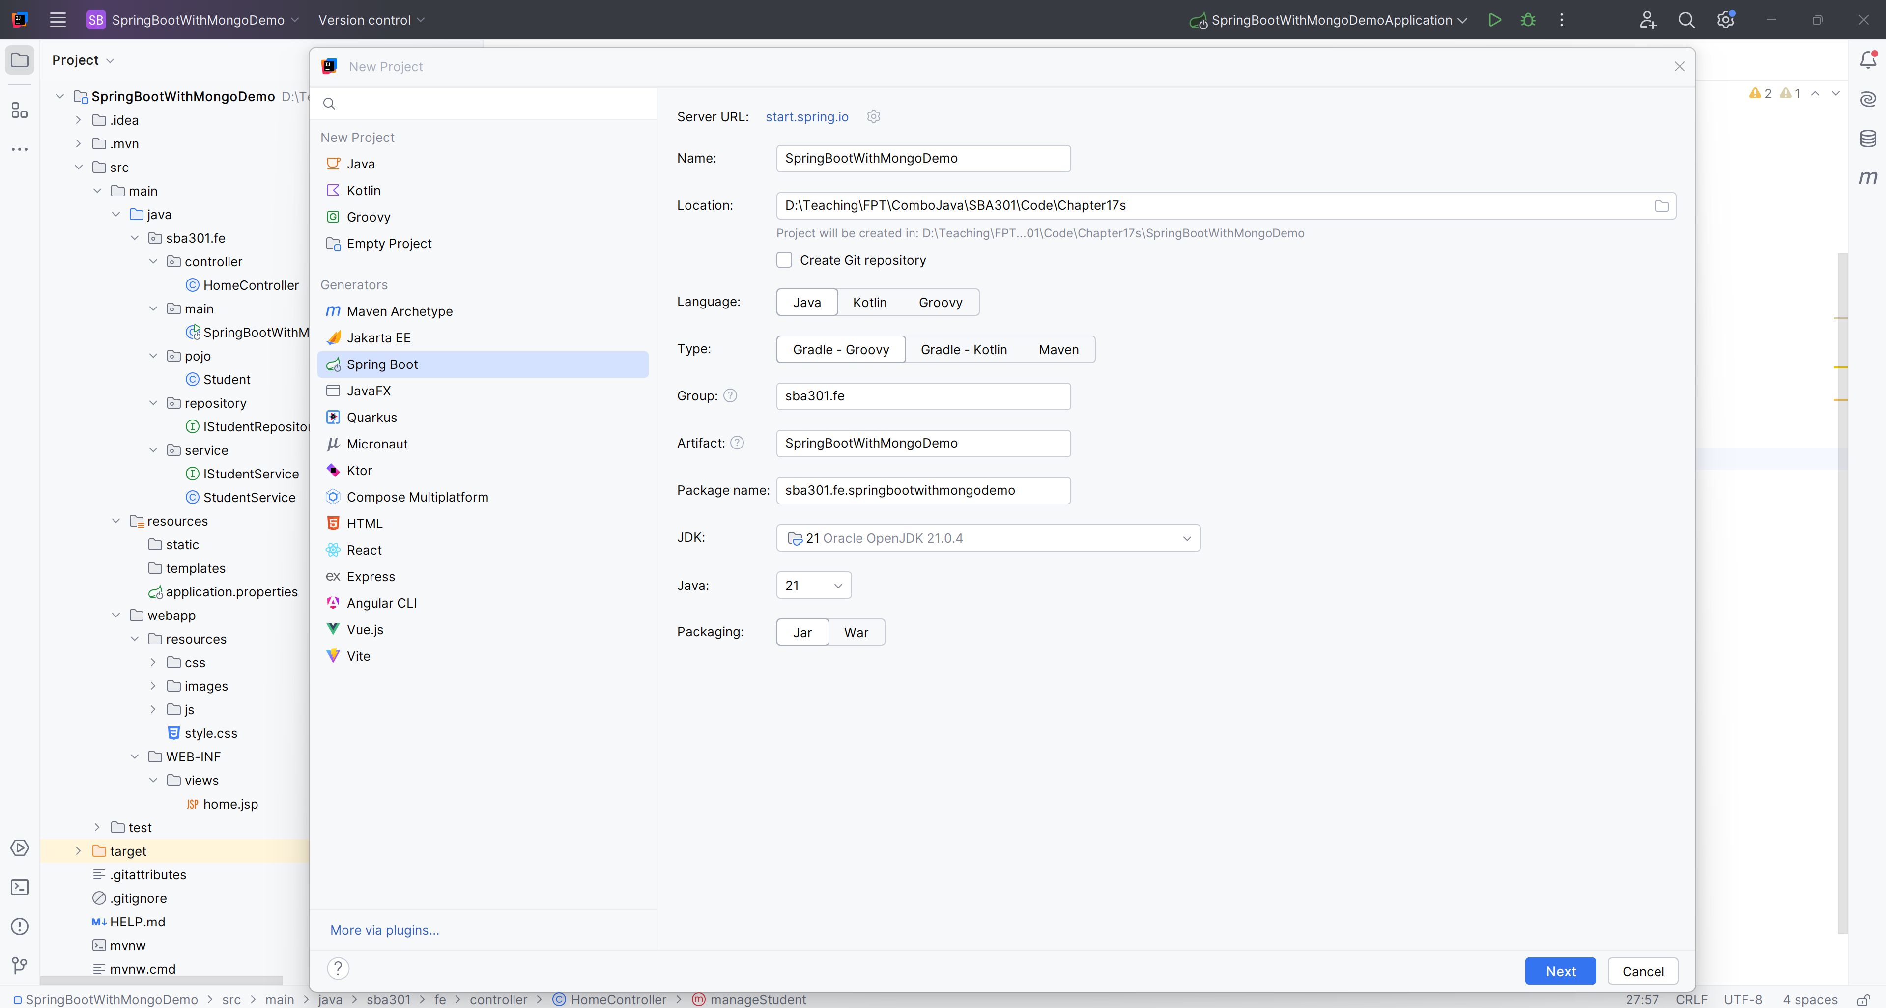

4

3

**Step 02.** Add Dependences

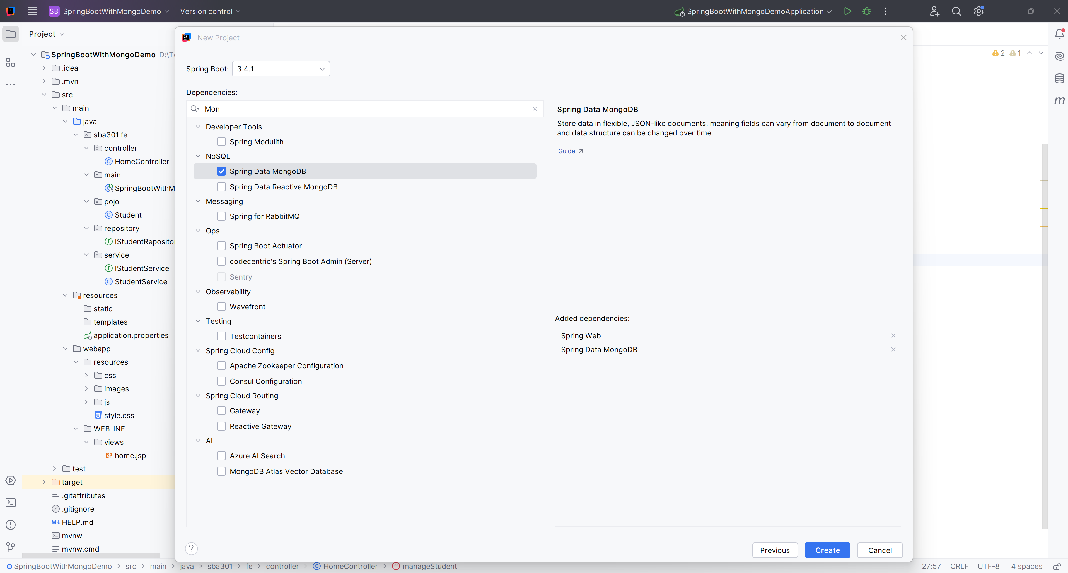

**Step 03**. Create the Structure Project

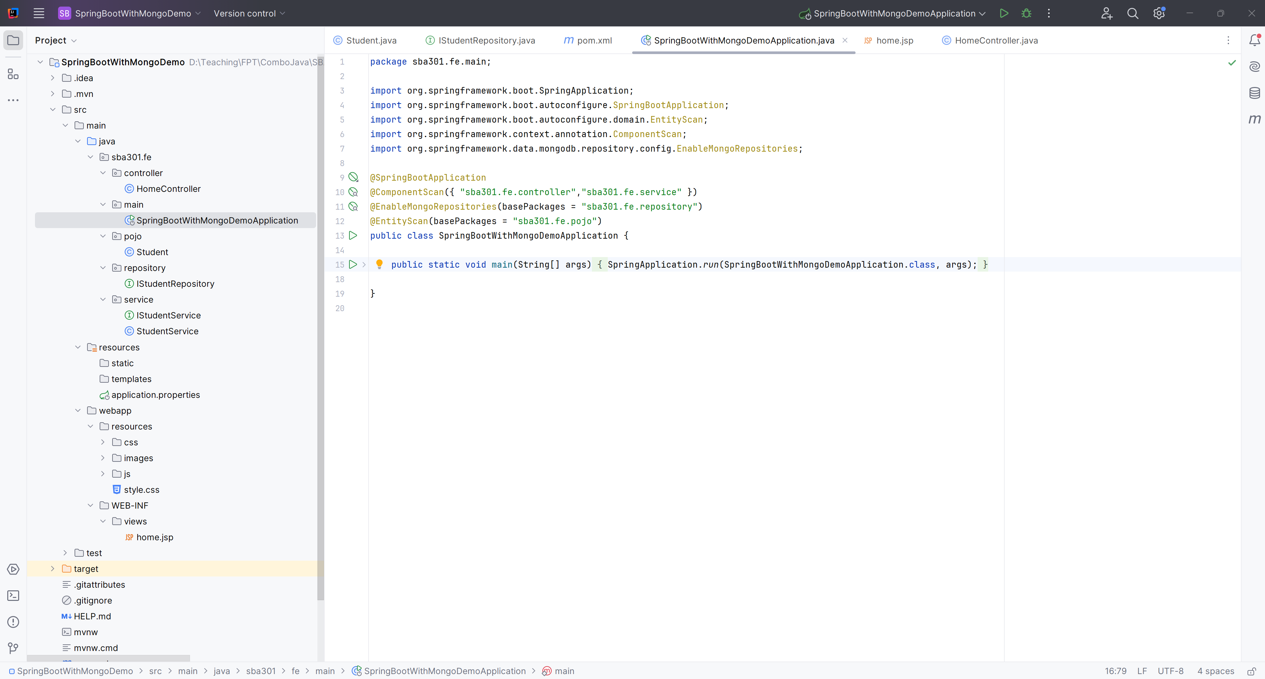

**Step 04**. Edit pom.xml

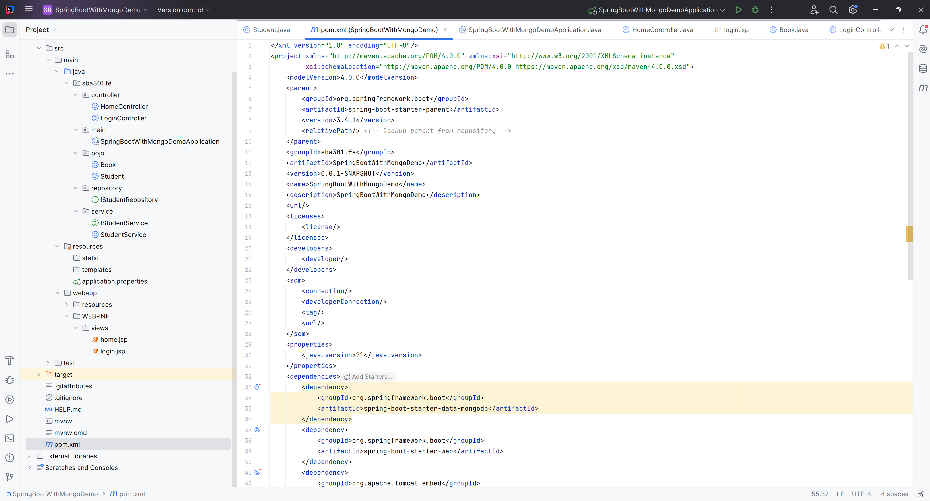

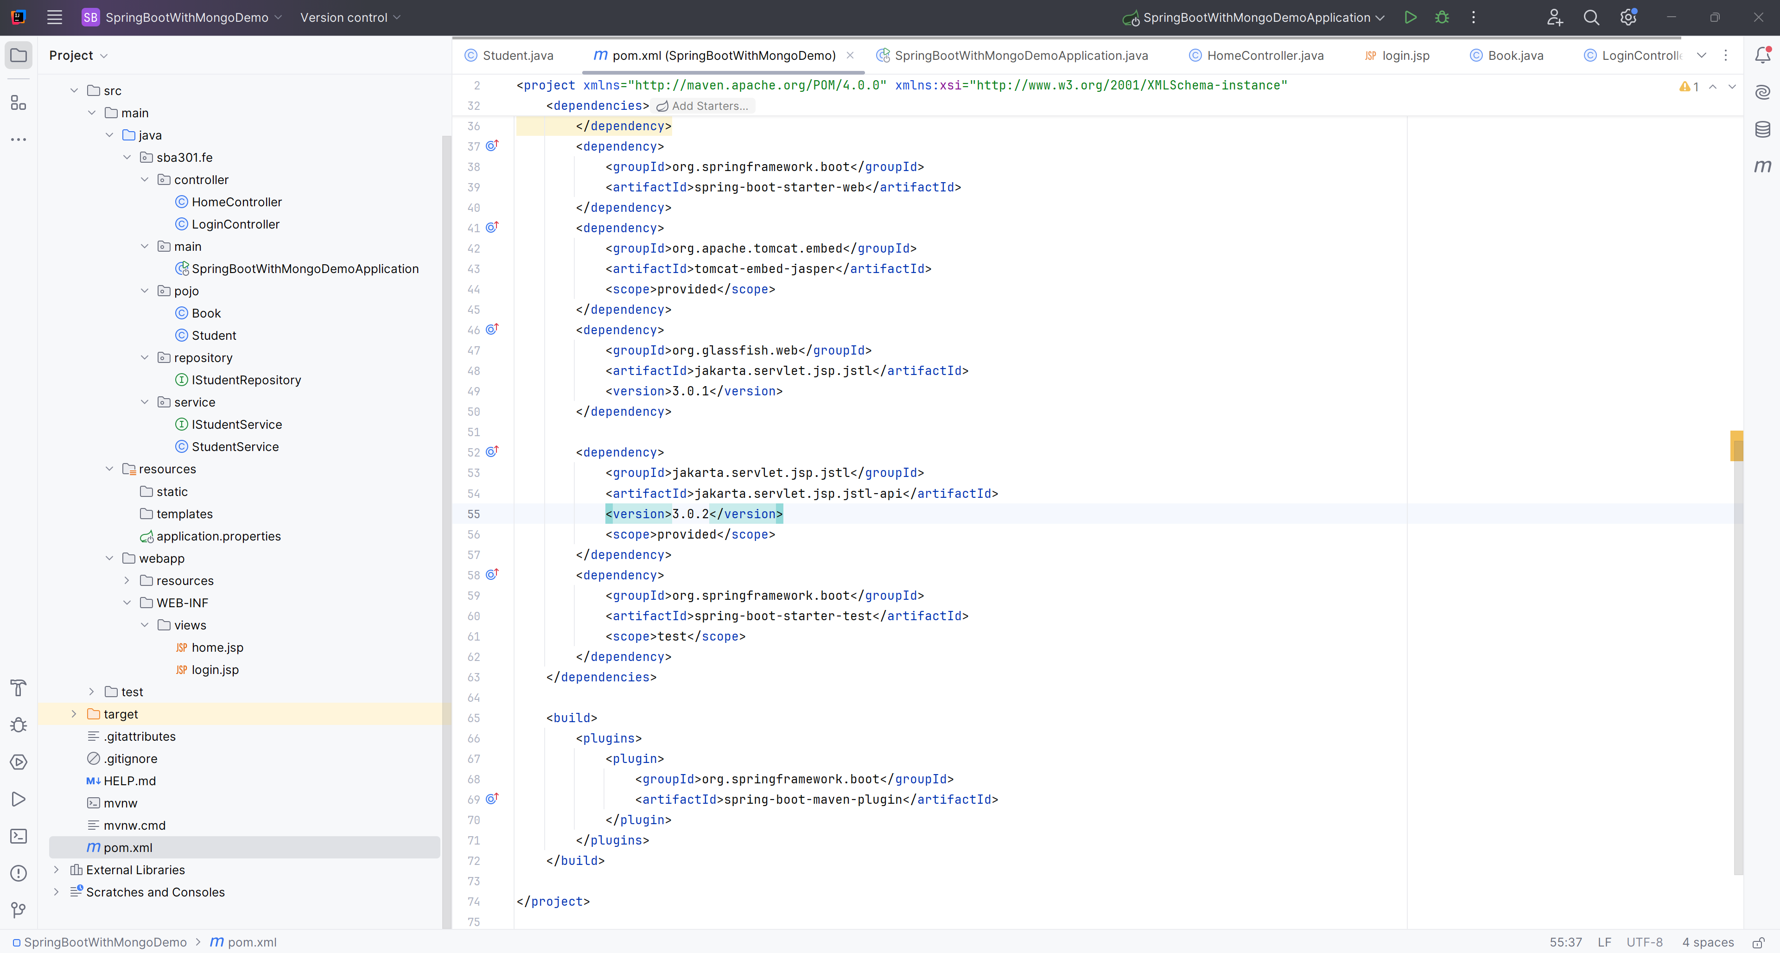

**Step 05**. Edit the application.properties

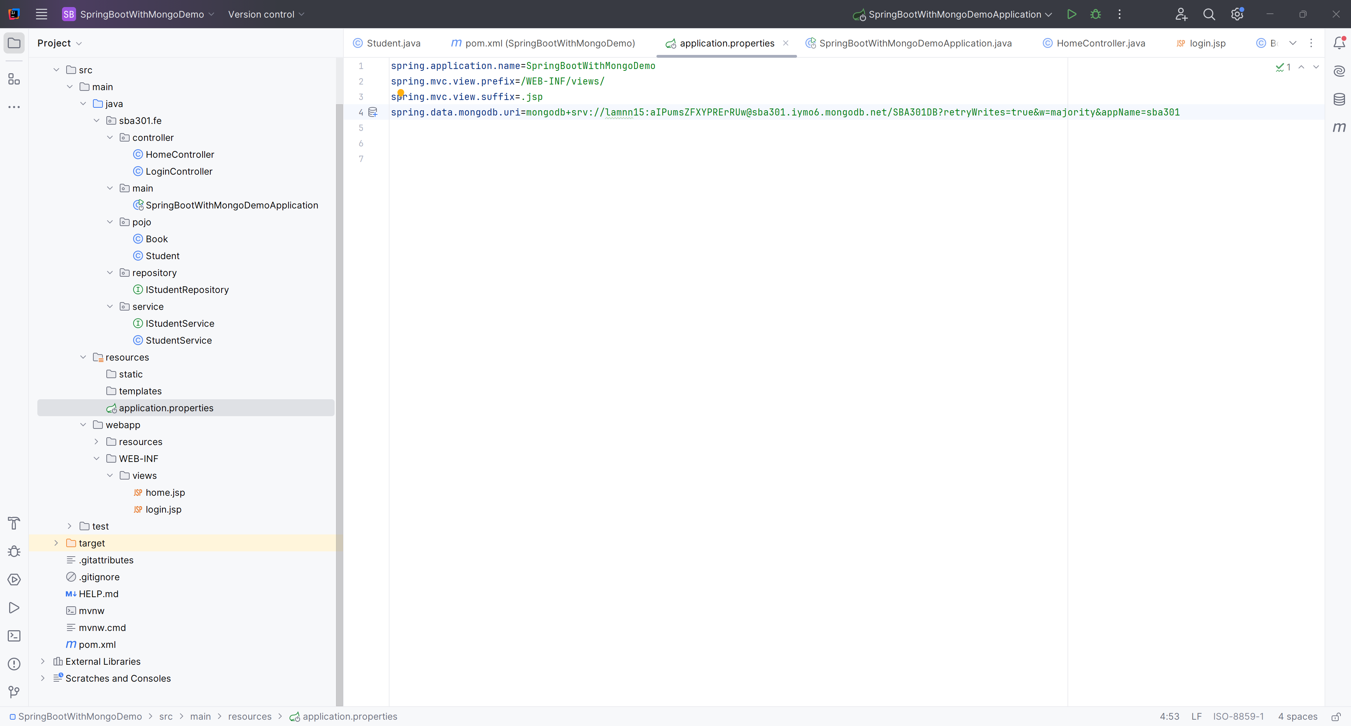

**Step 06**. Copy material into project

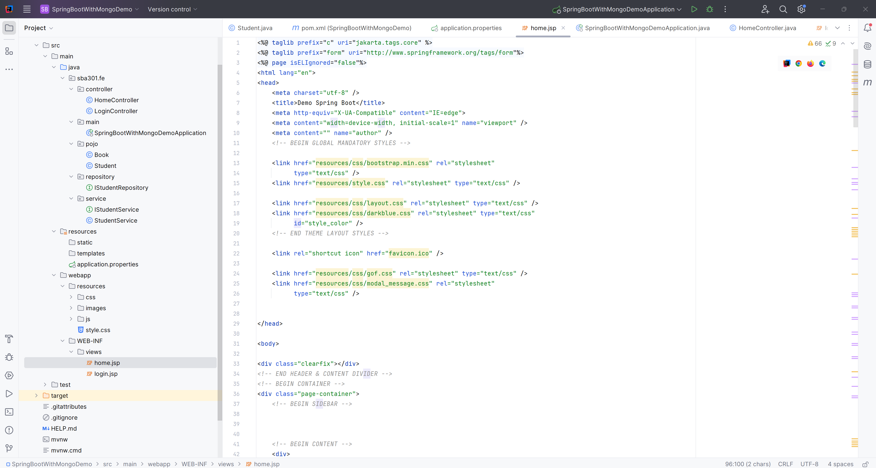

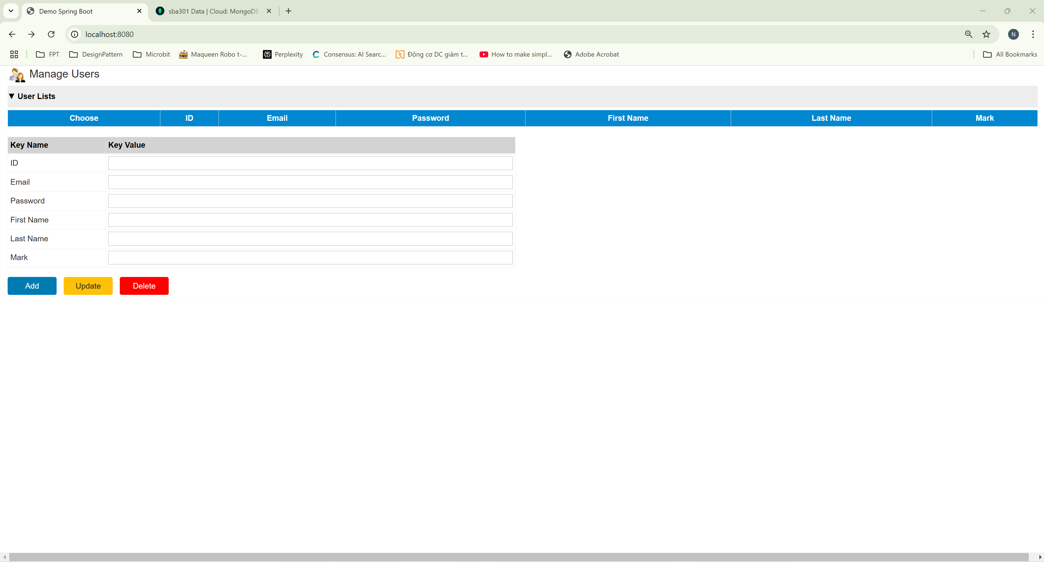

**Step 07**. Edit home.jsp

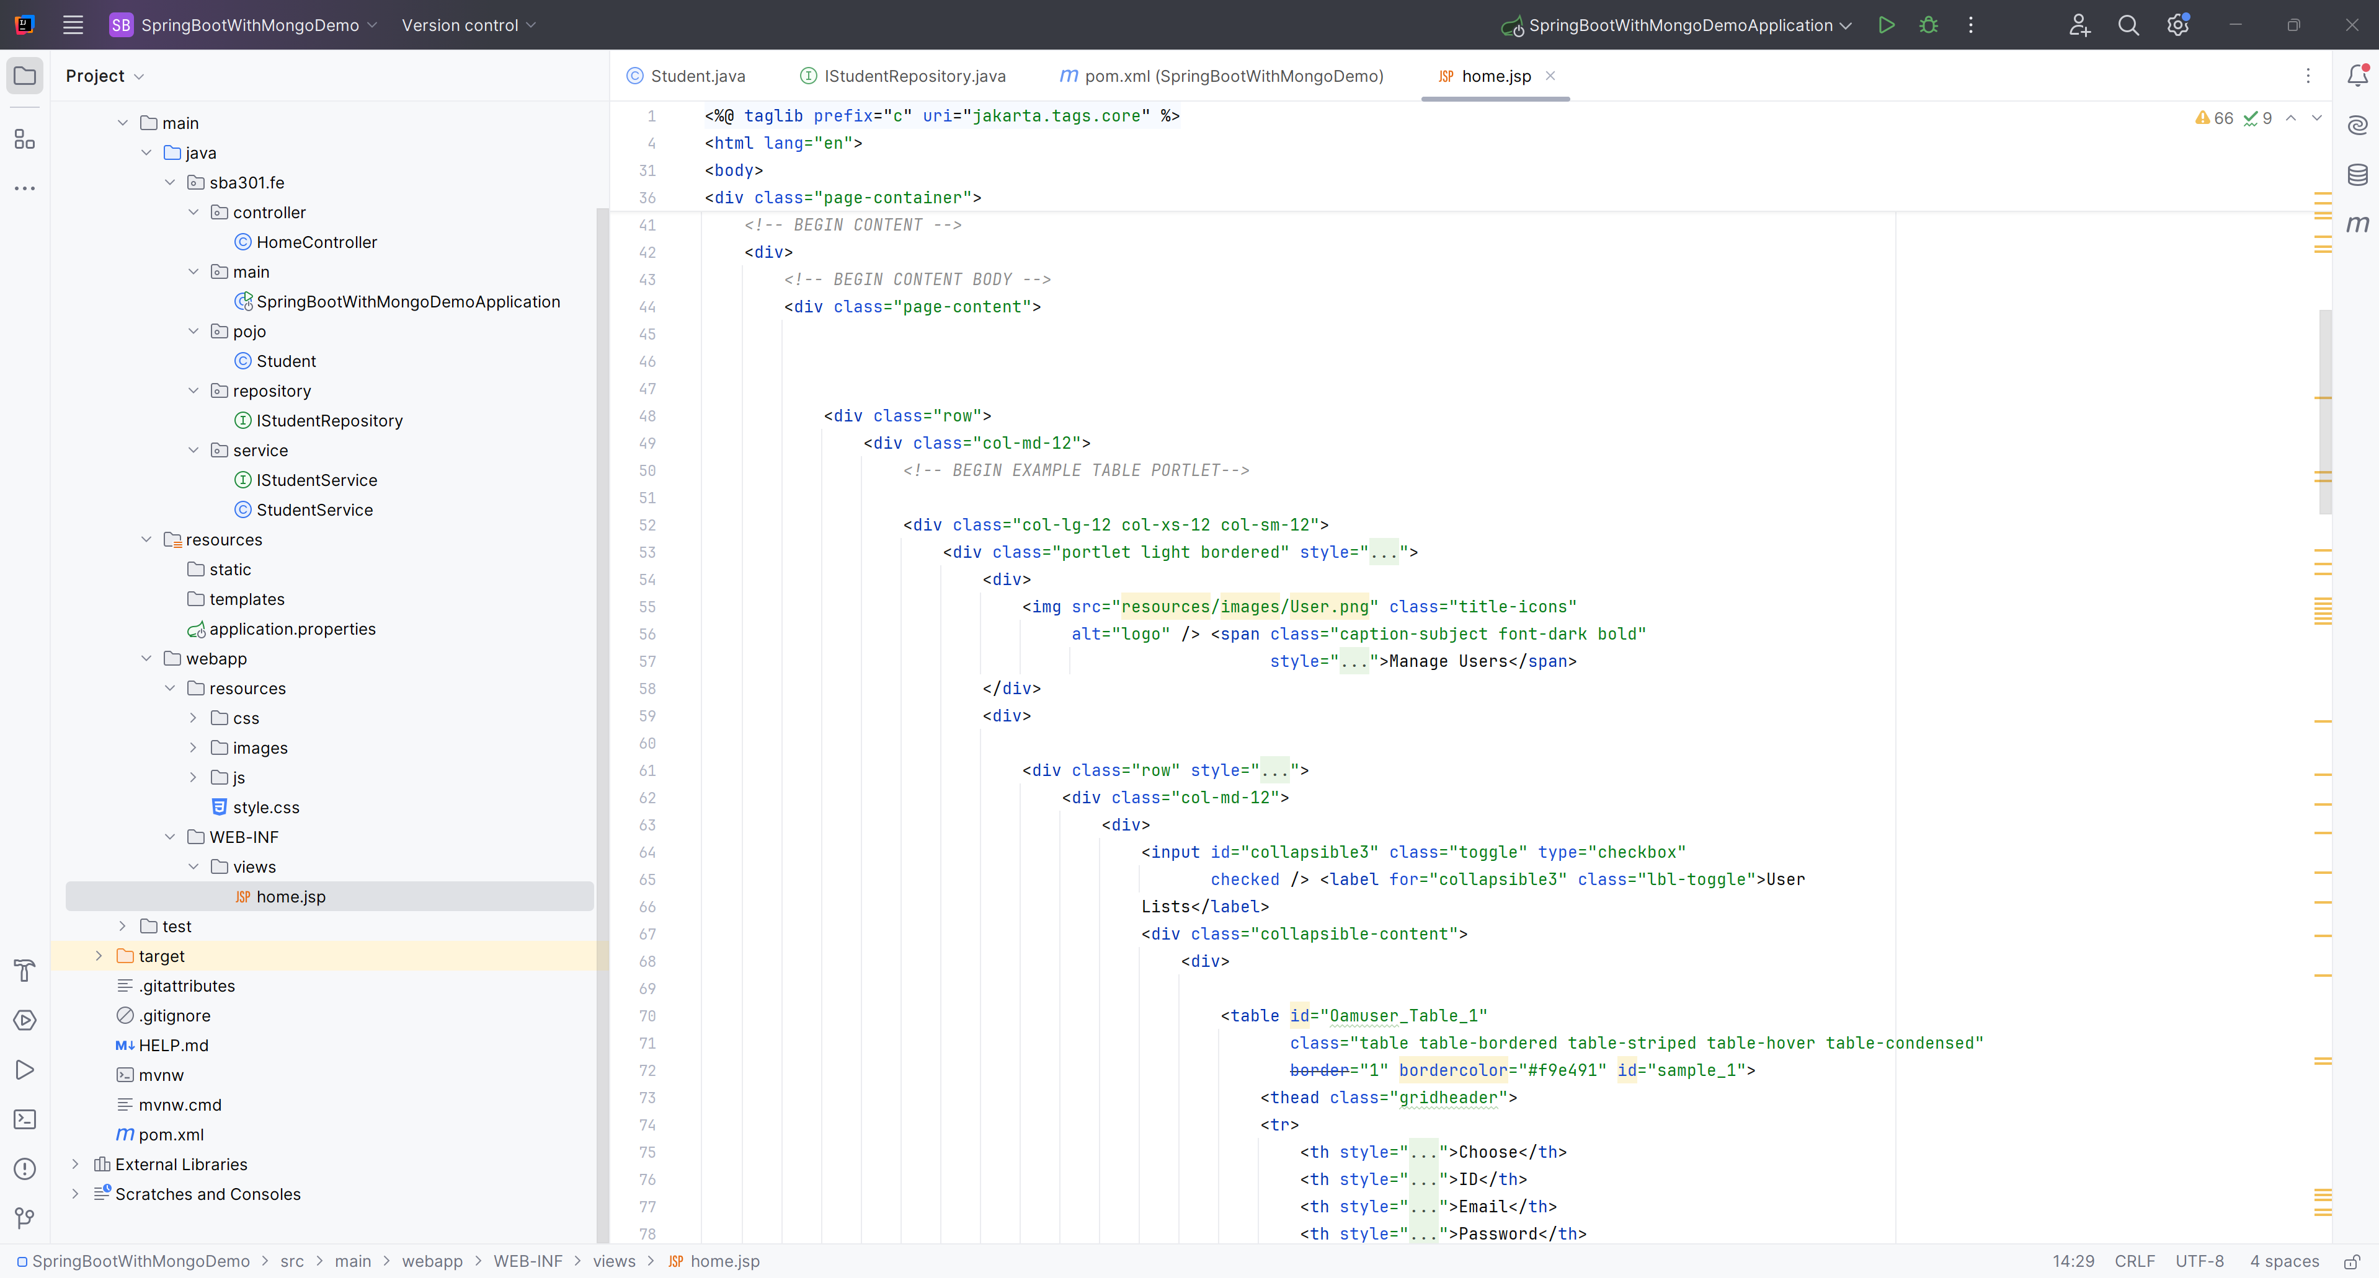

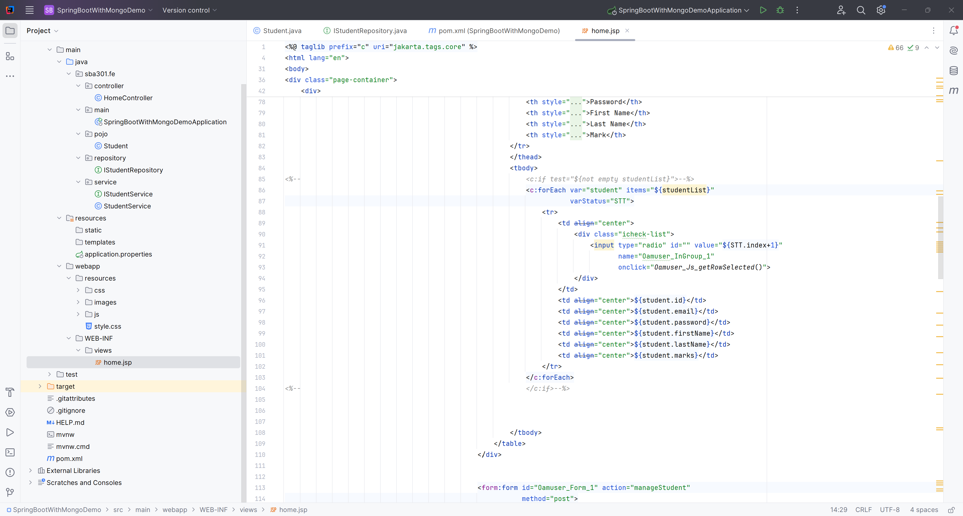

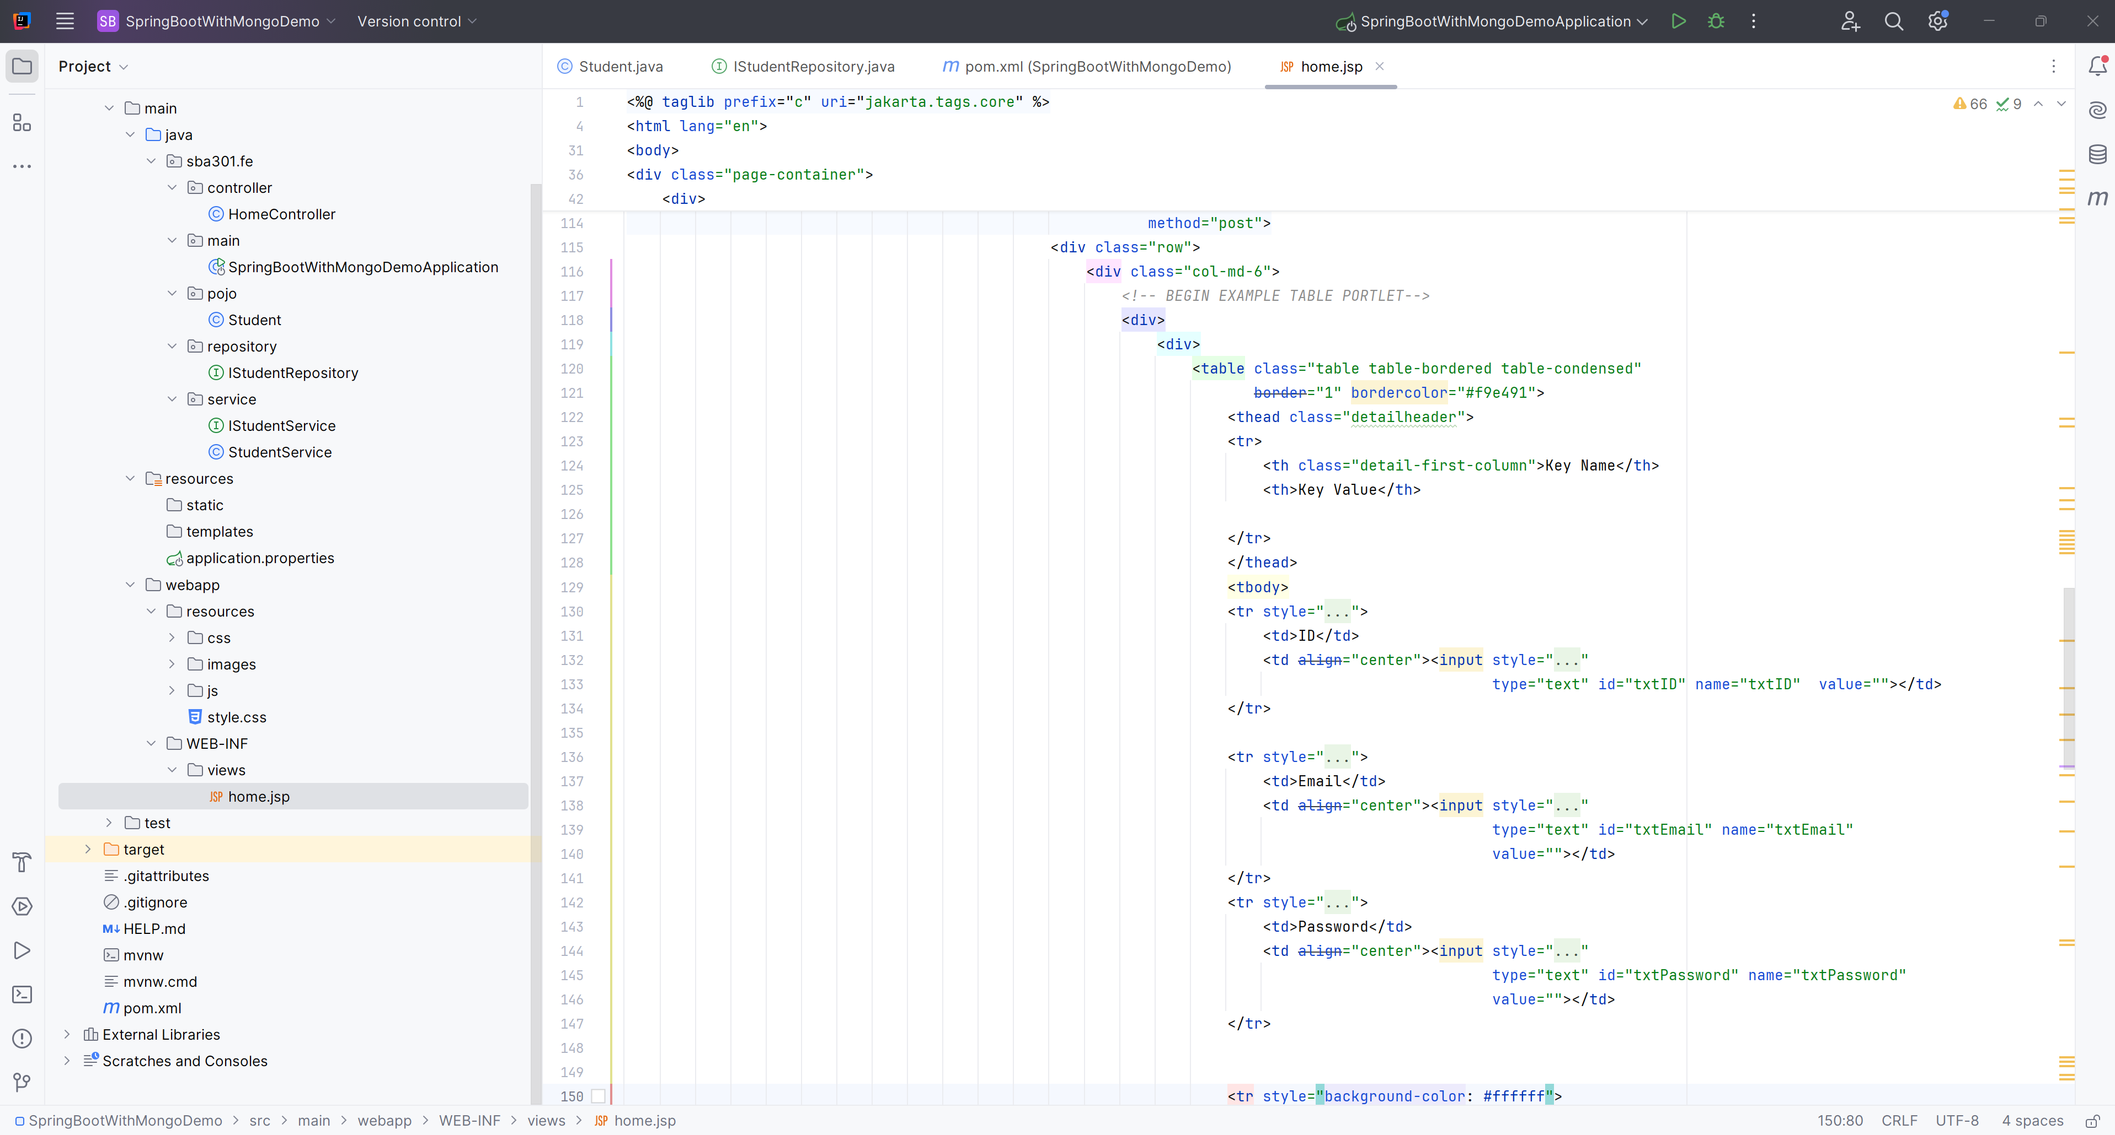

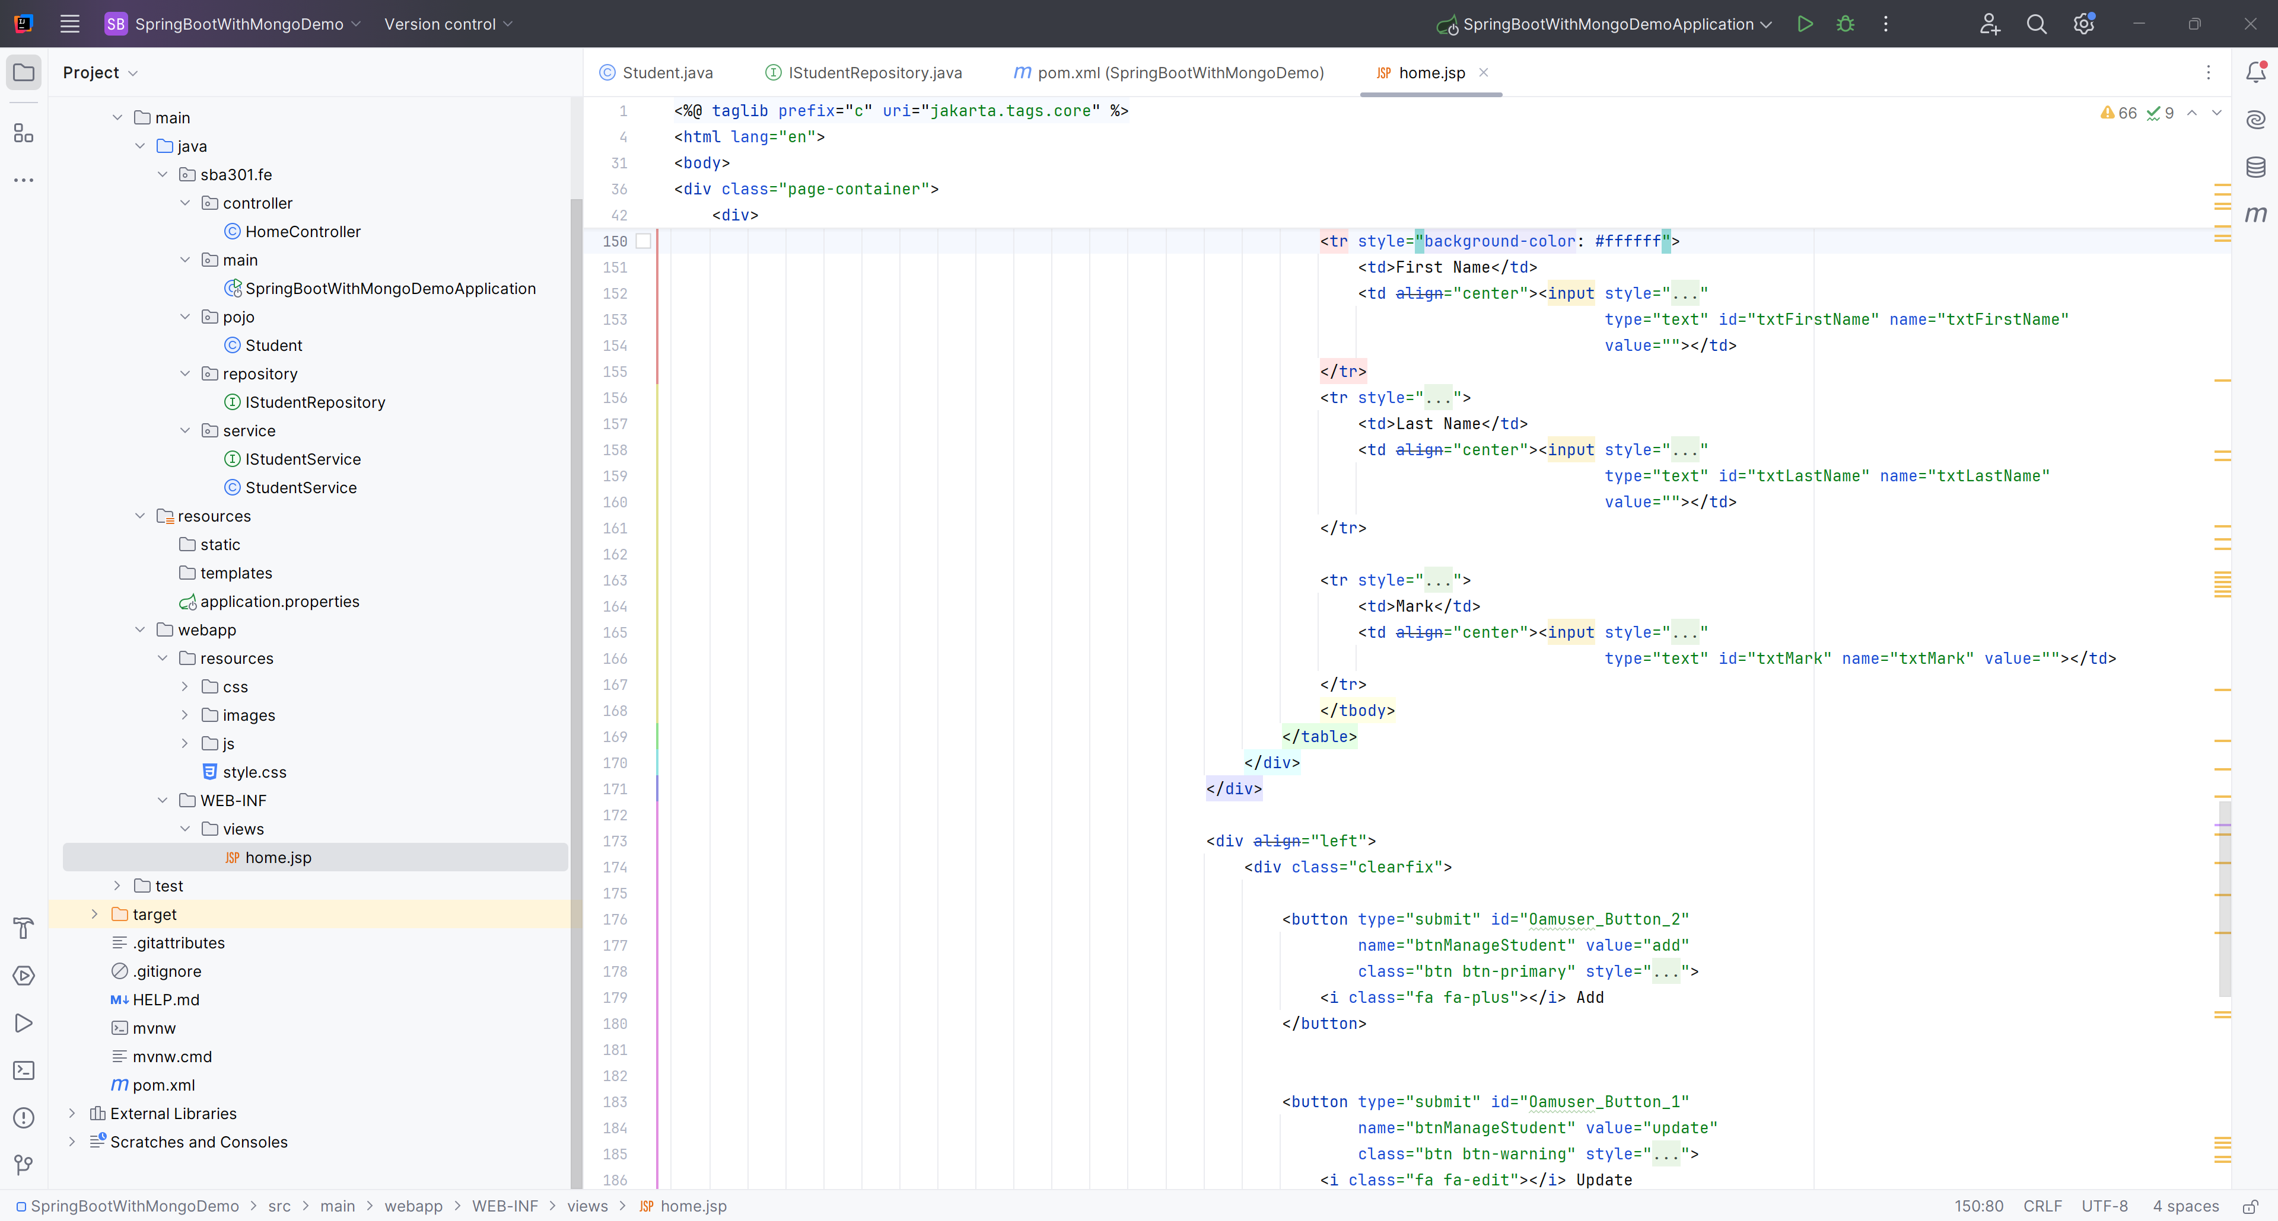

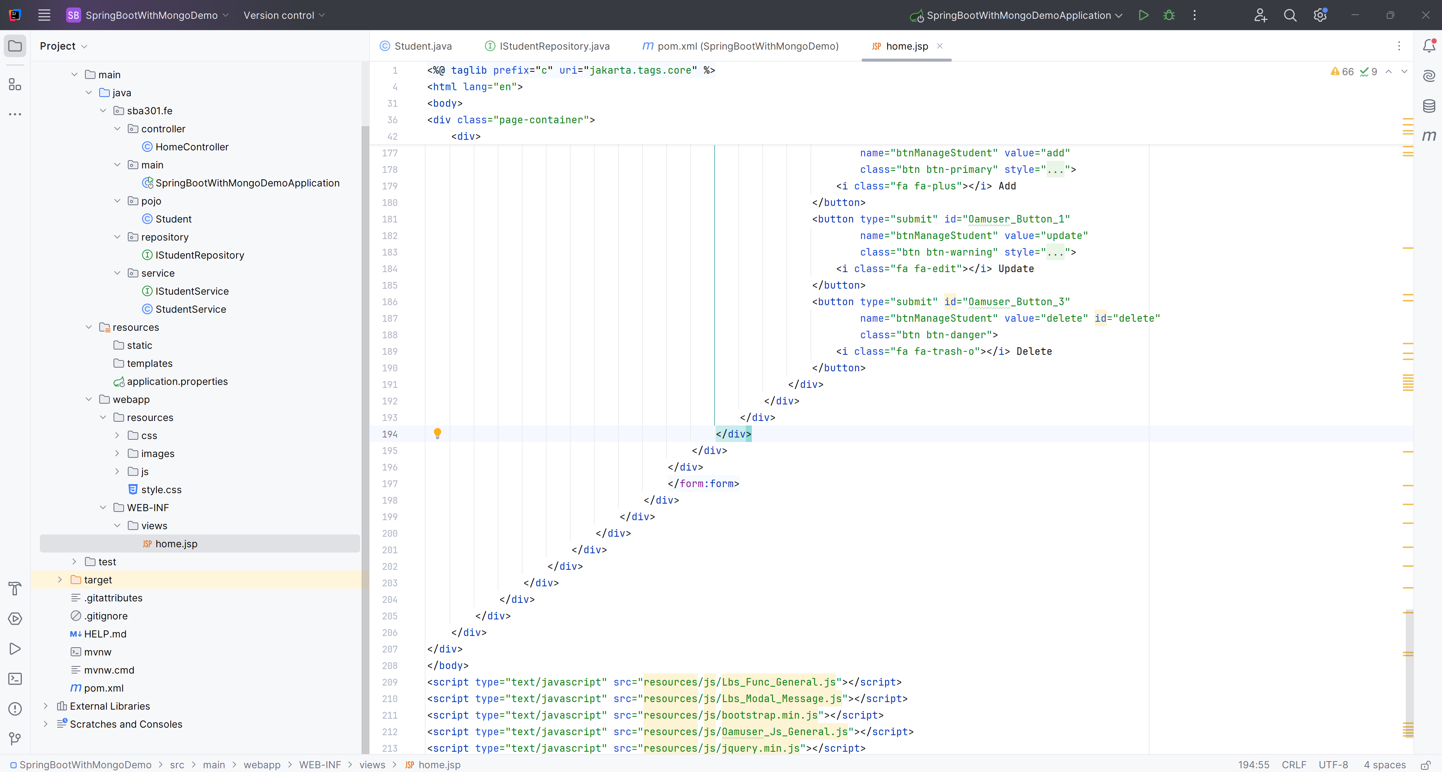

**Step 08**. Create the login.jsp

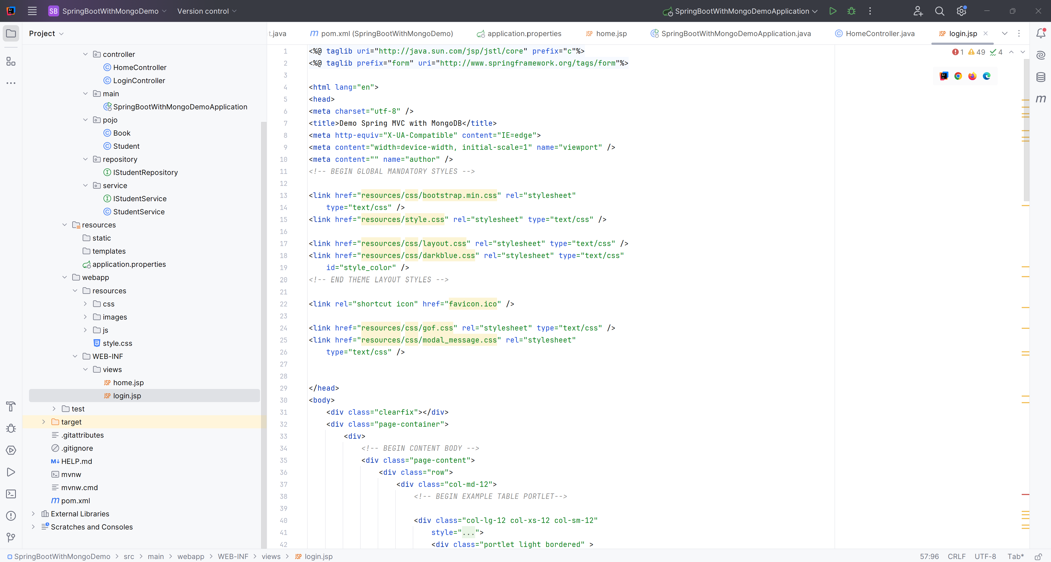

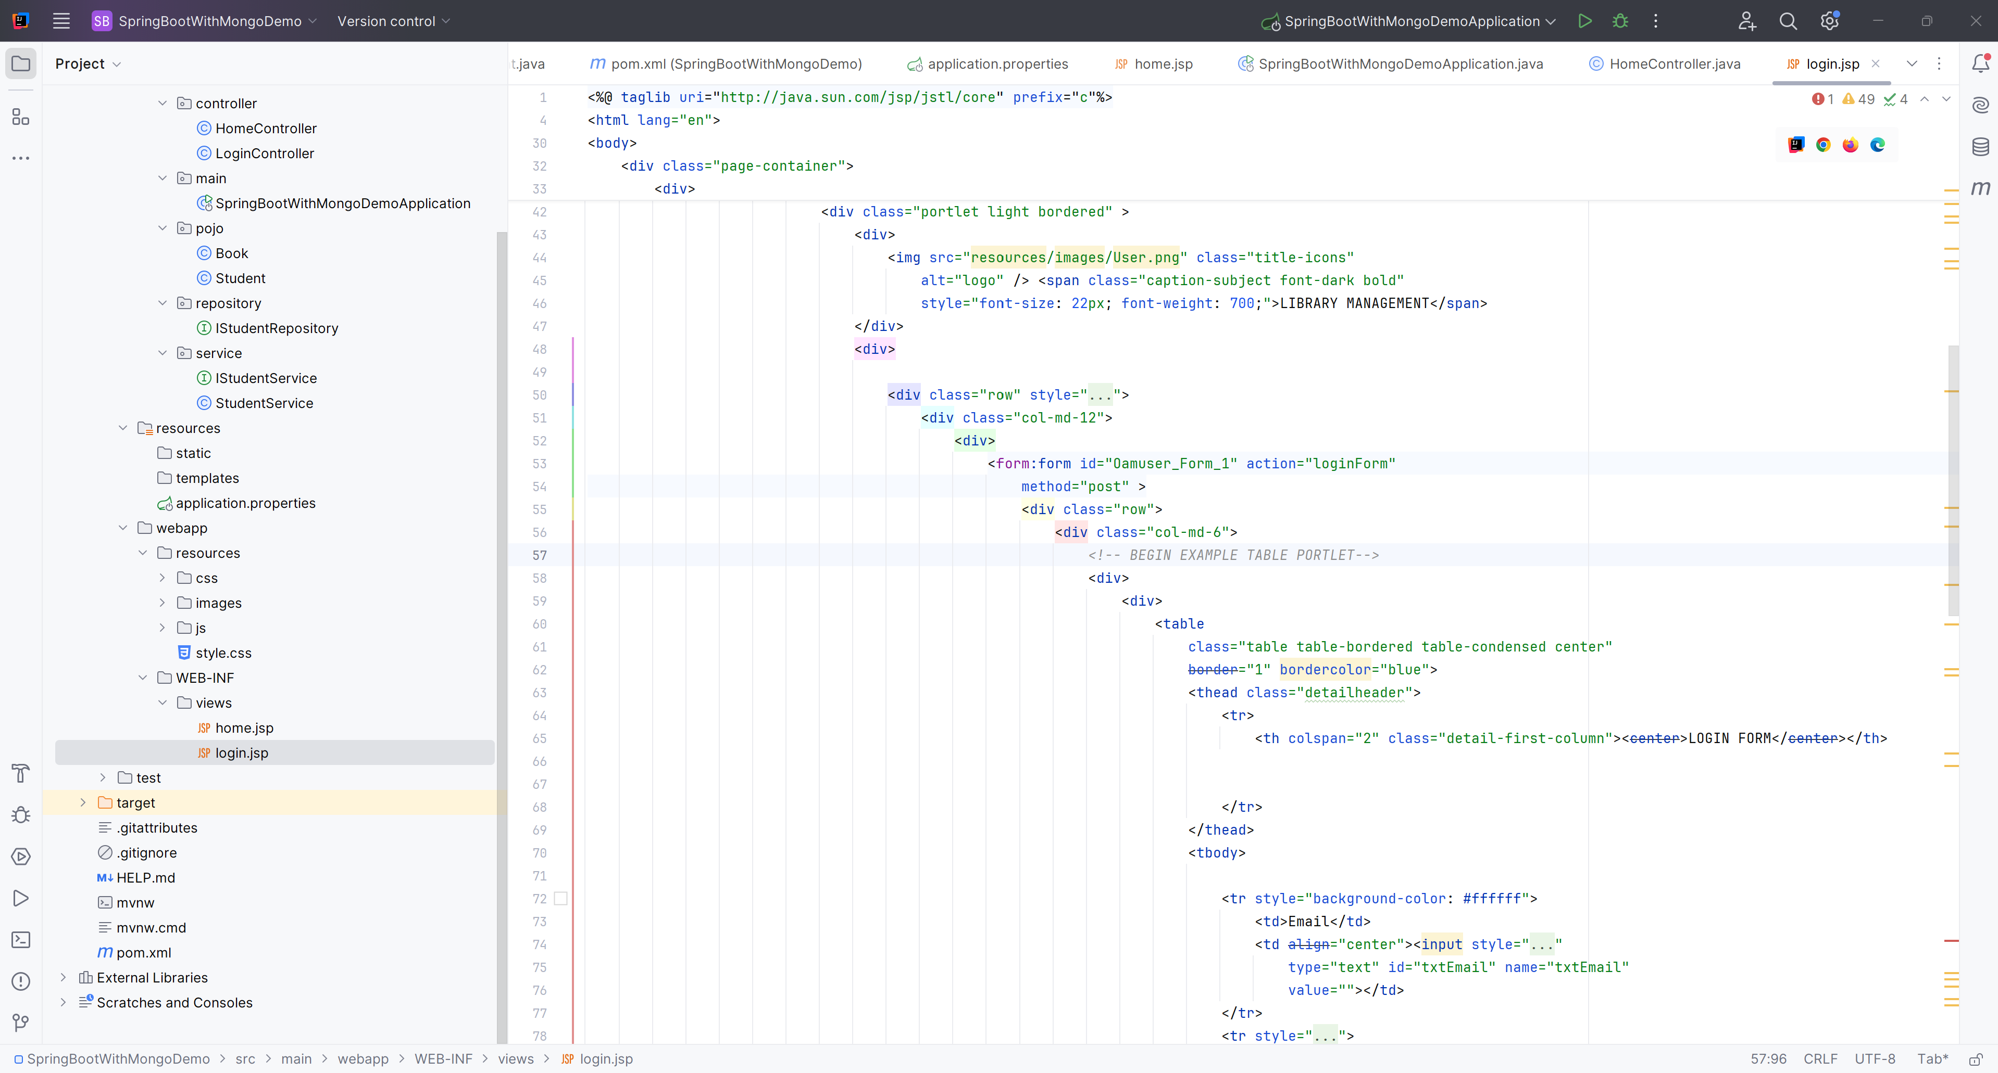

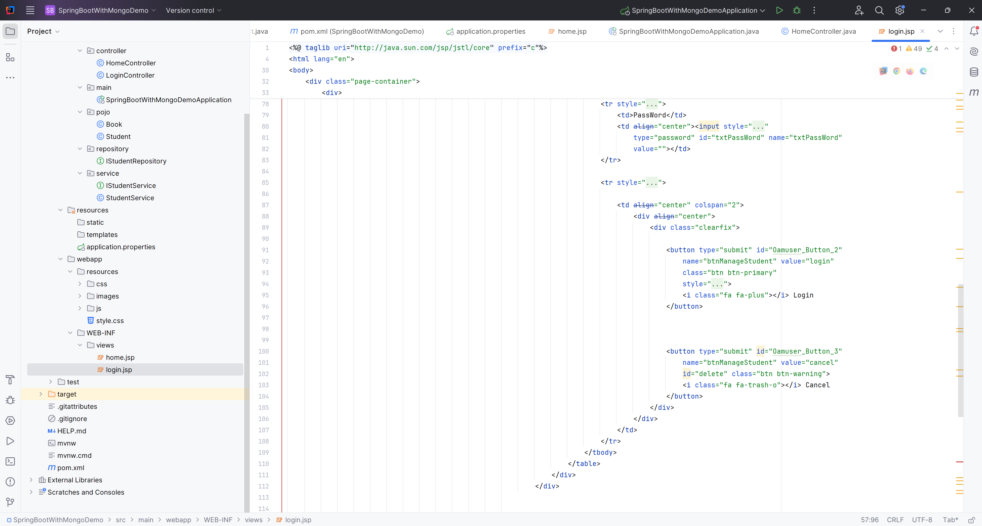  
  
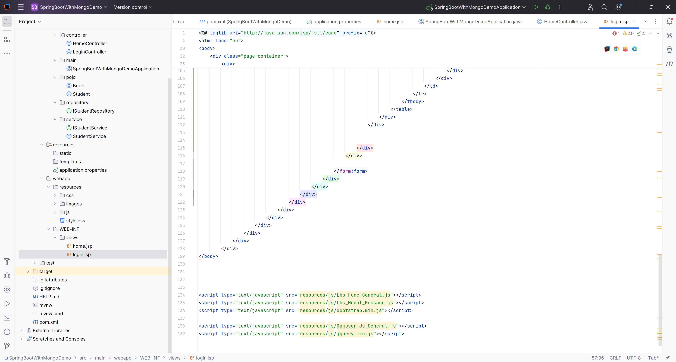

# Activity 02: Develop the Architecture with Repository Pattern and show the Student List

**Step 01.** Build the Architecture

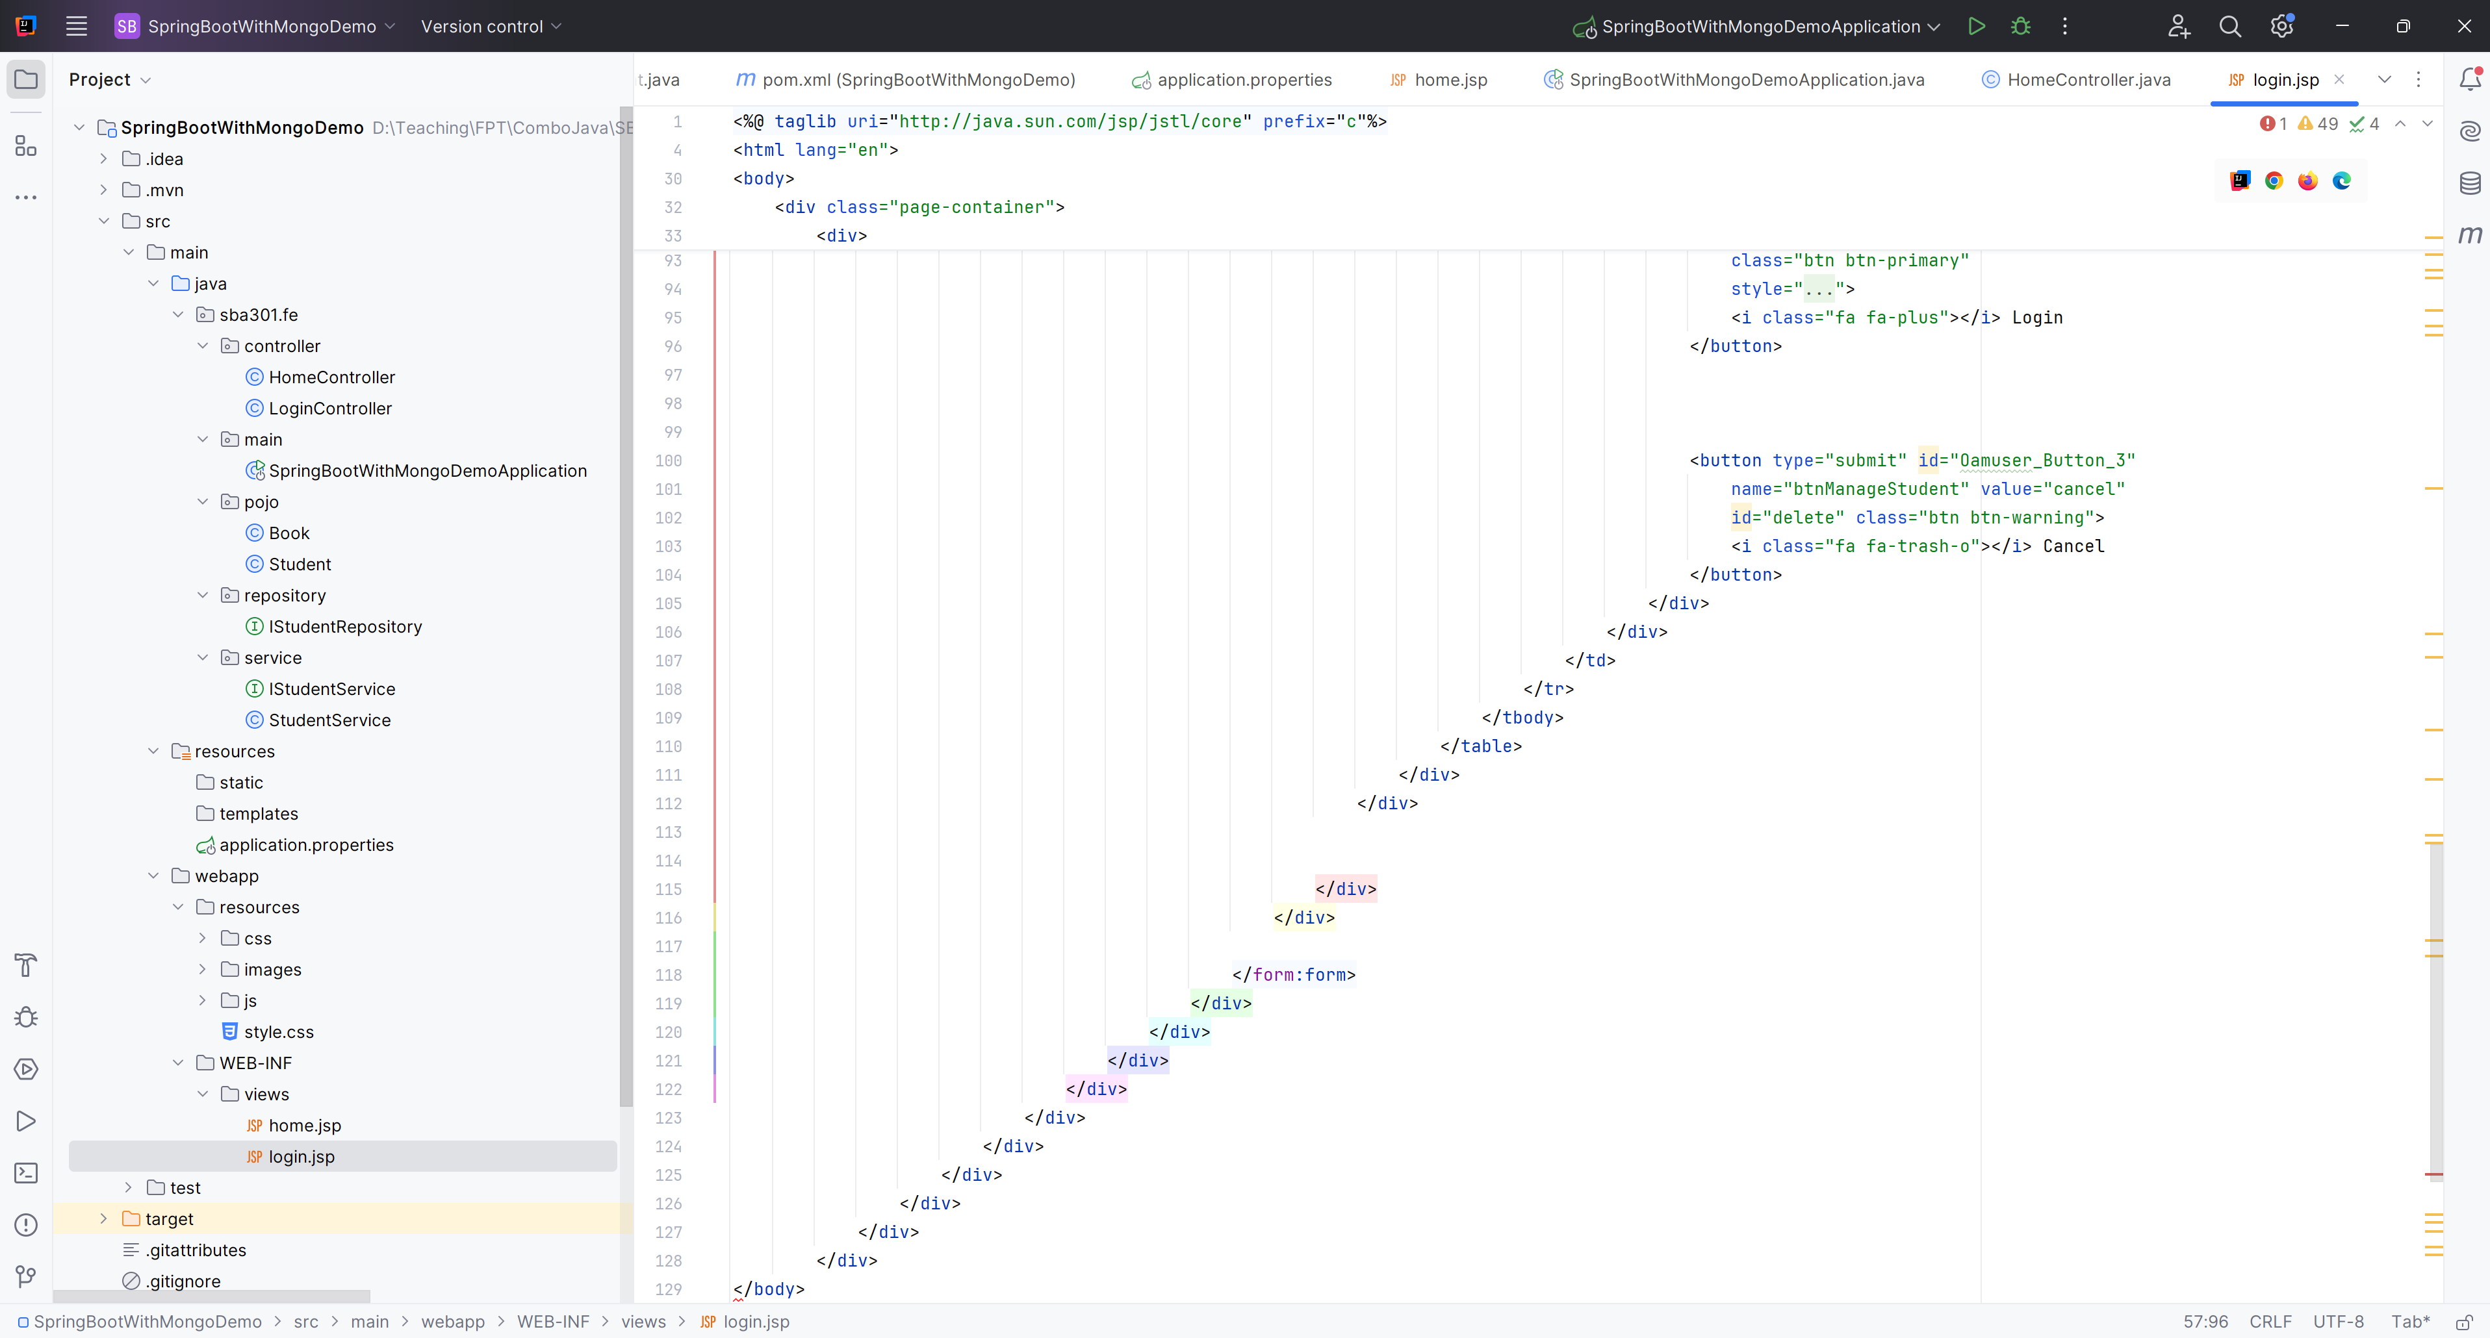

**Step 02**. Create Books in Pojo

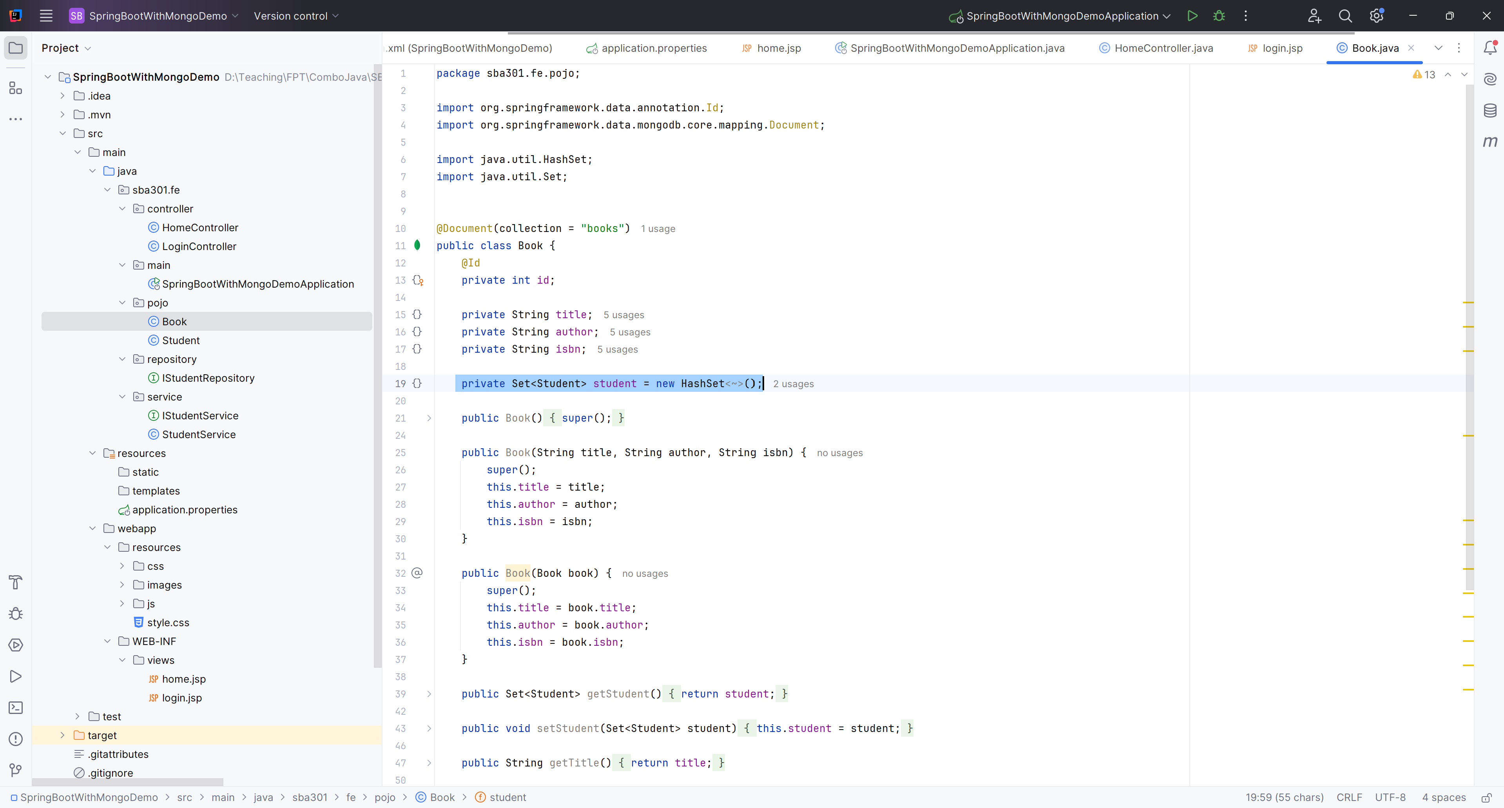

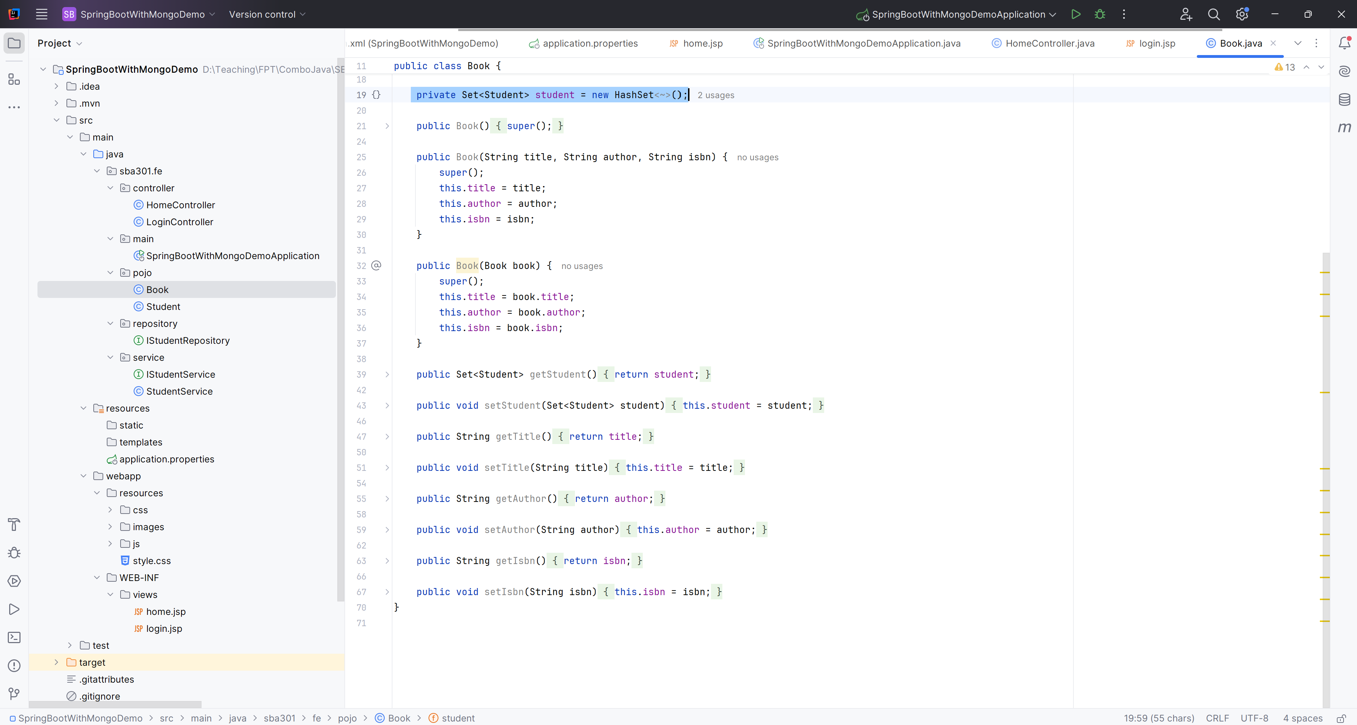

**Step 03**. Create Students in Pojo

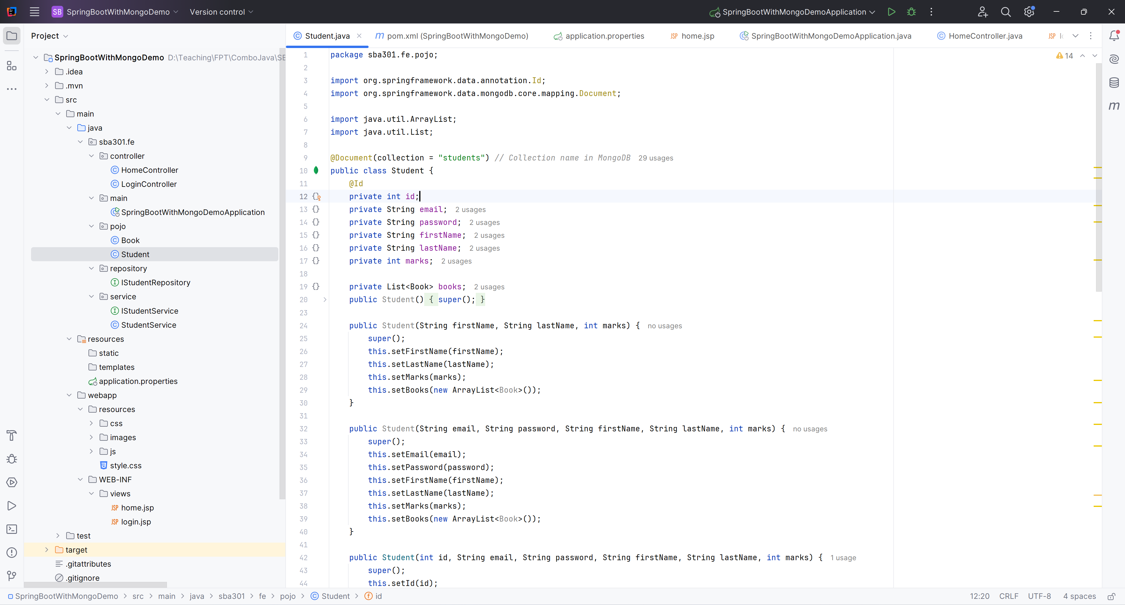

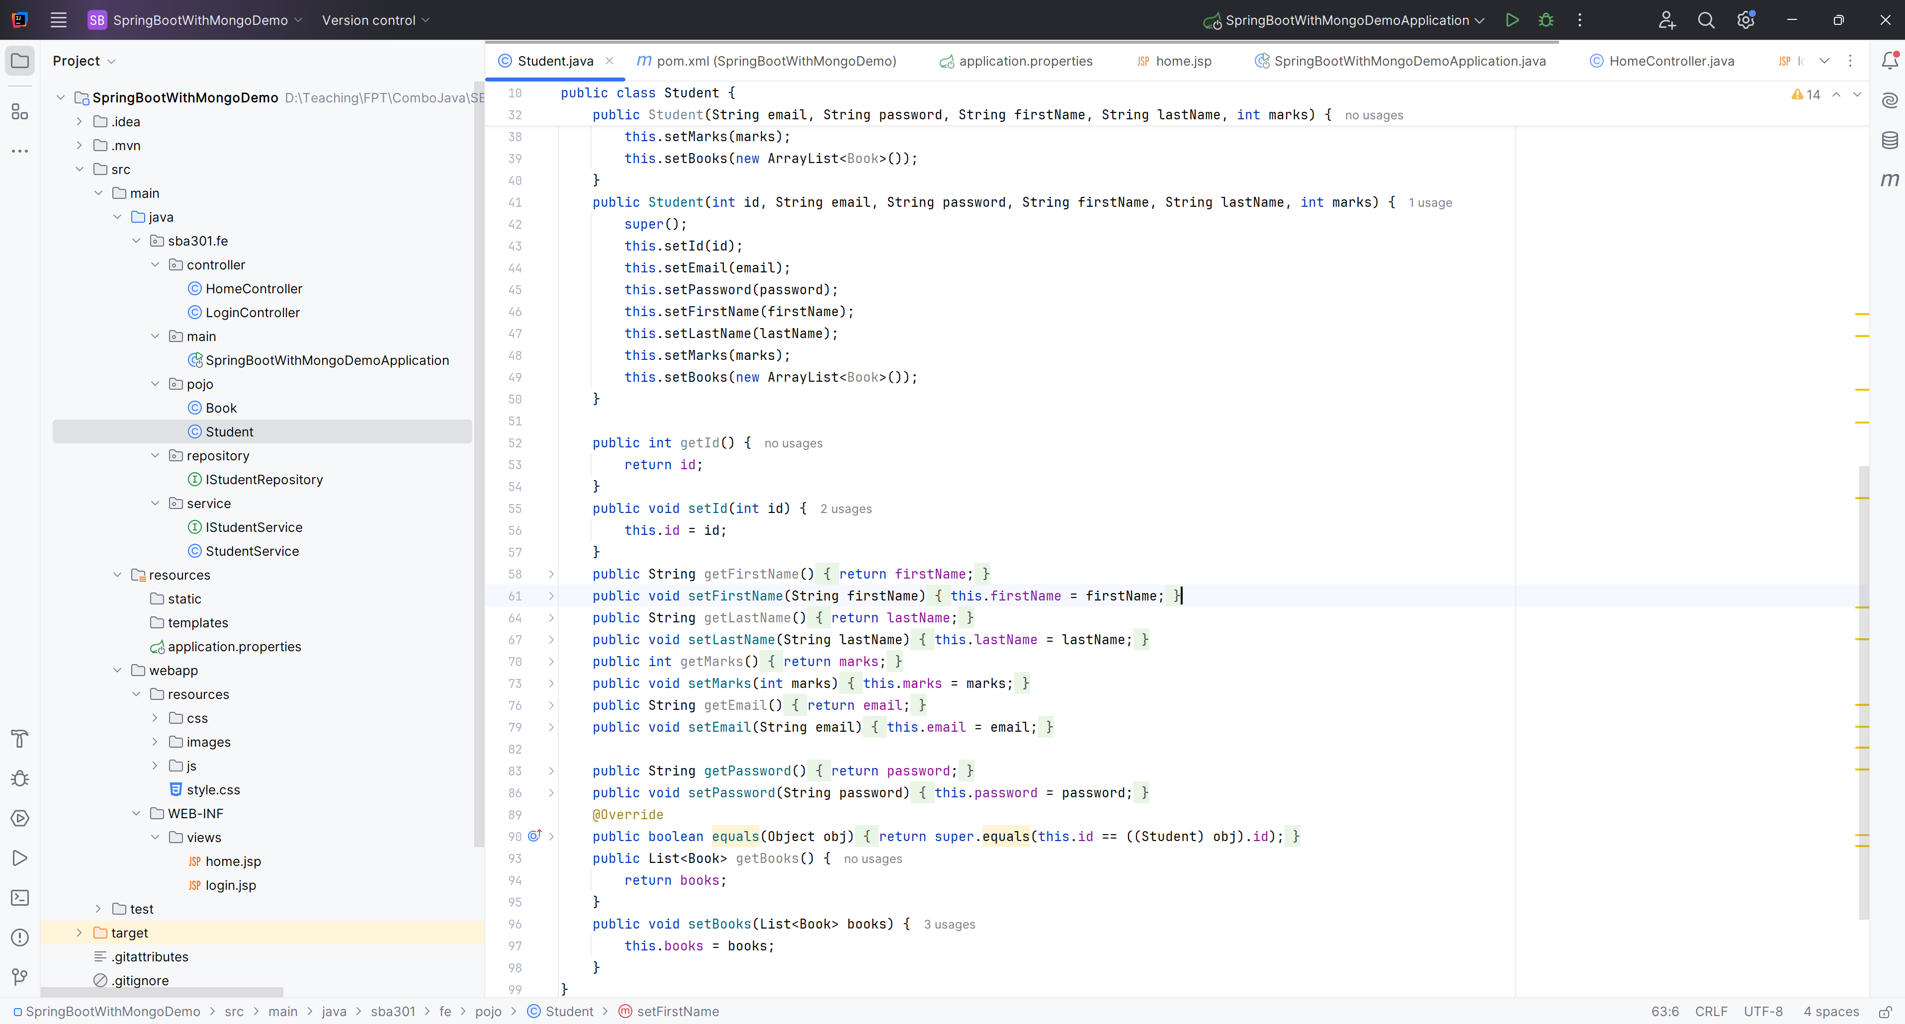

**Step 04**. Create IStudentRepository in Repository Package

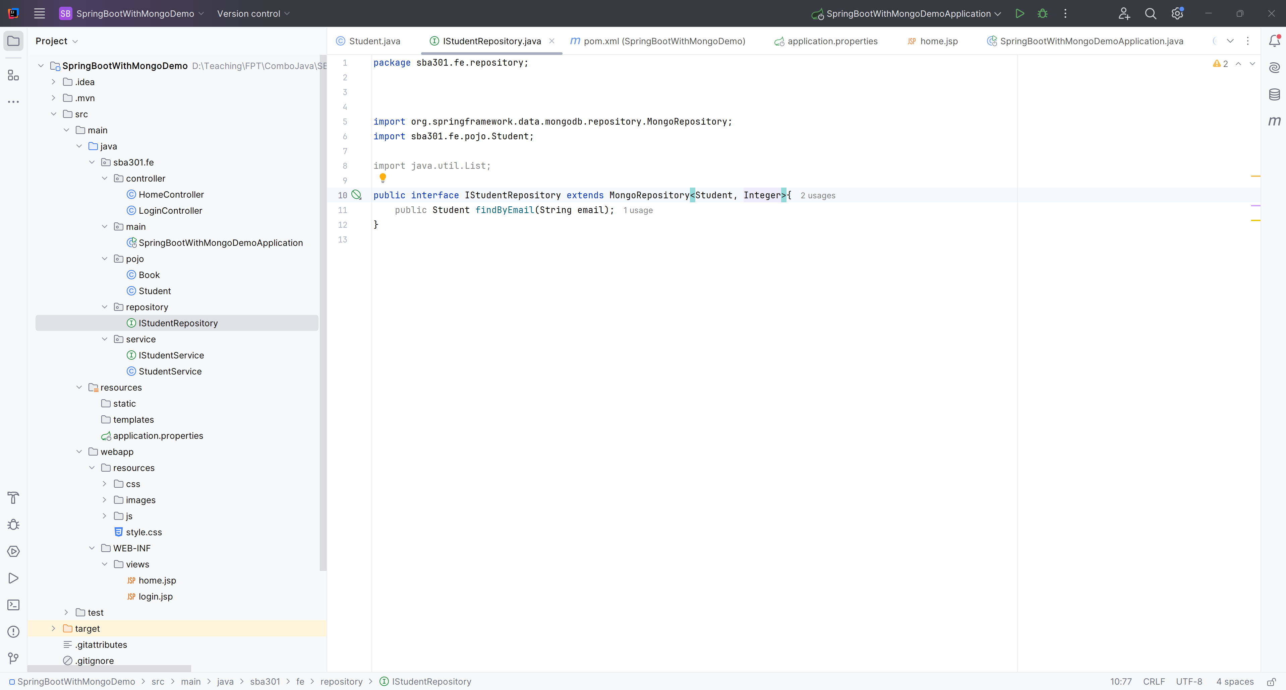

**Step 05**. Create IStudentService in Service Package

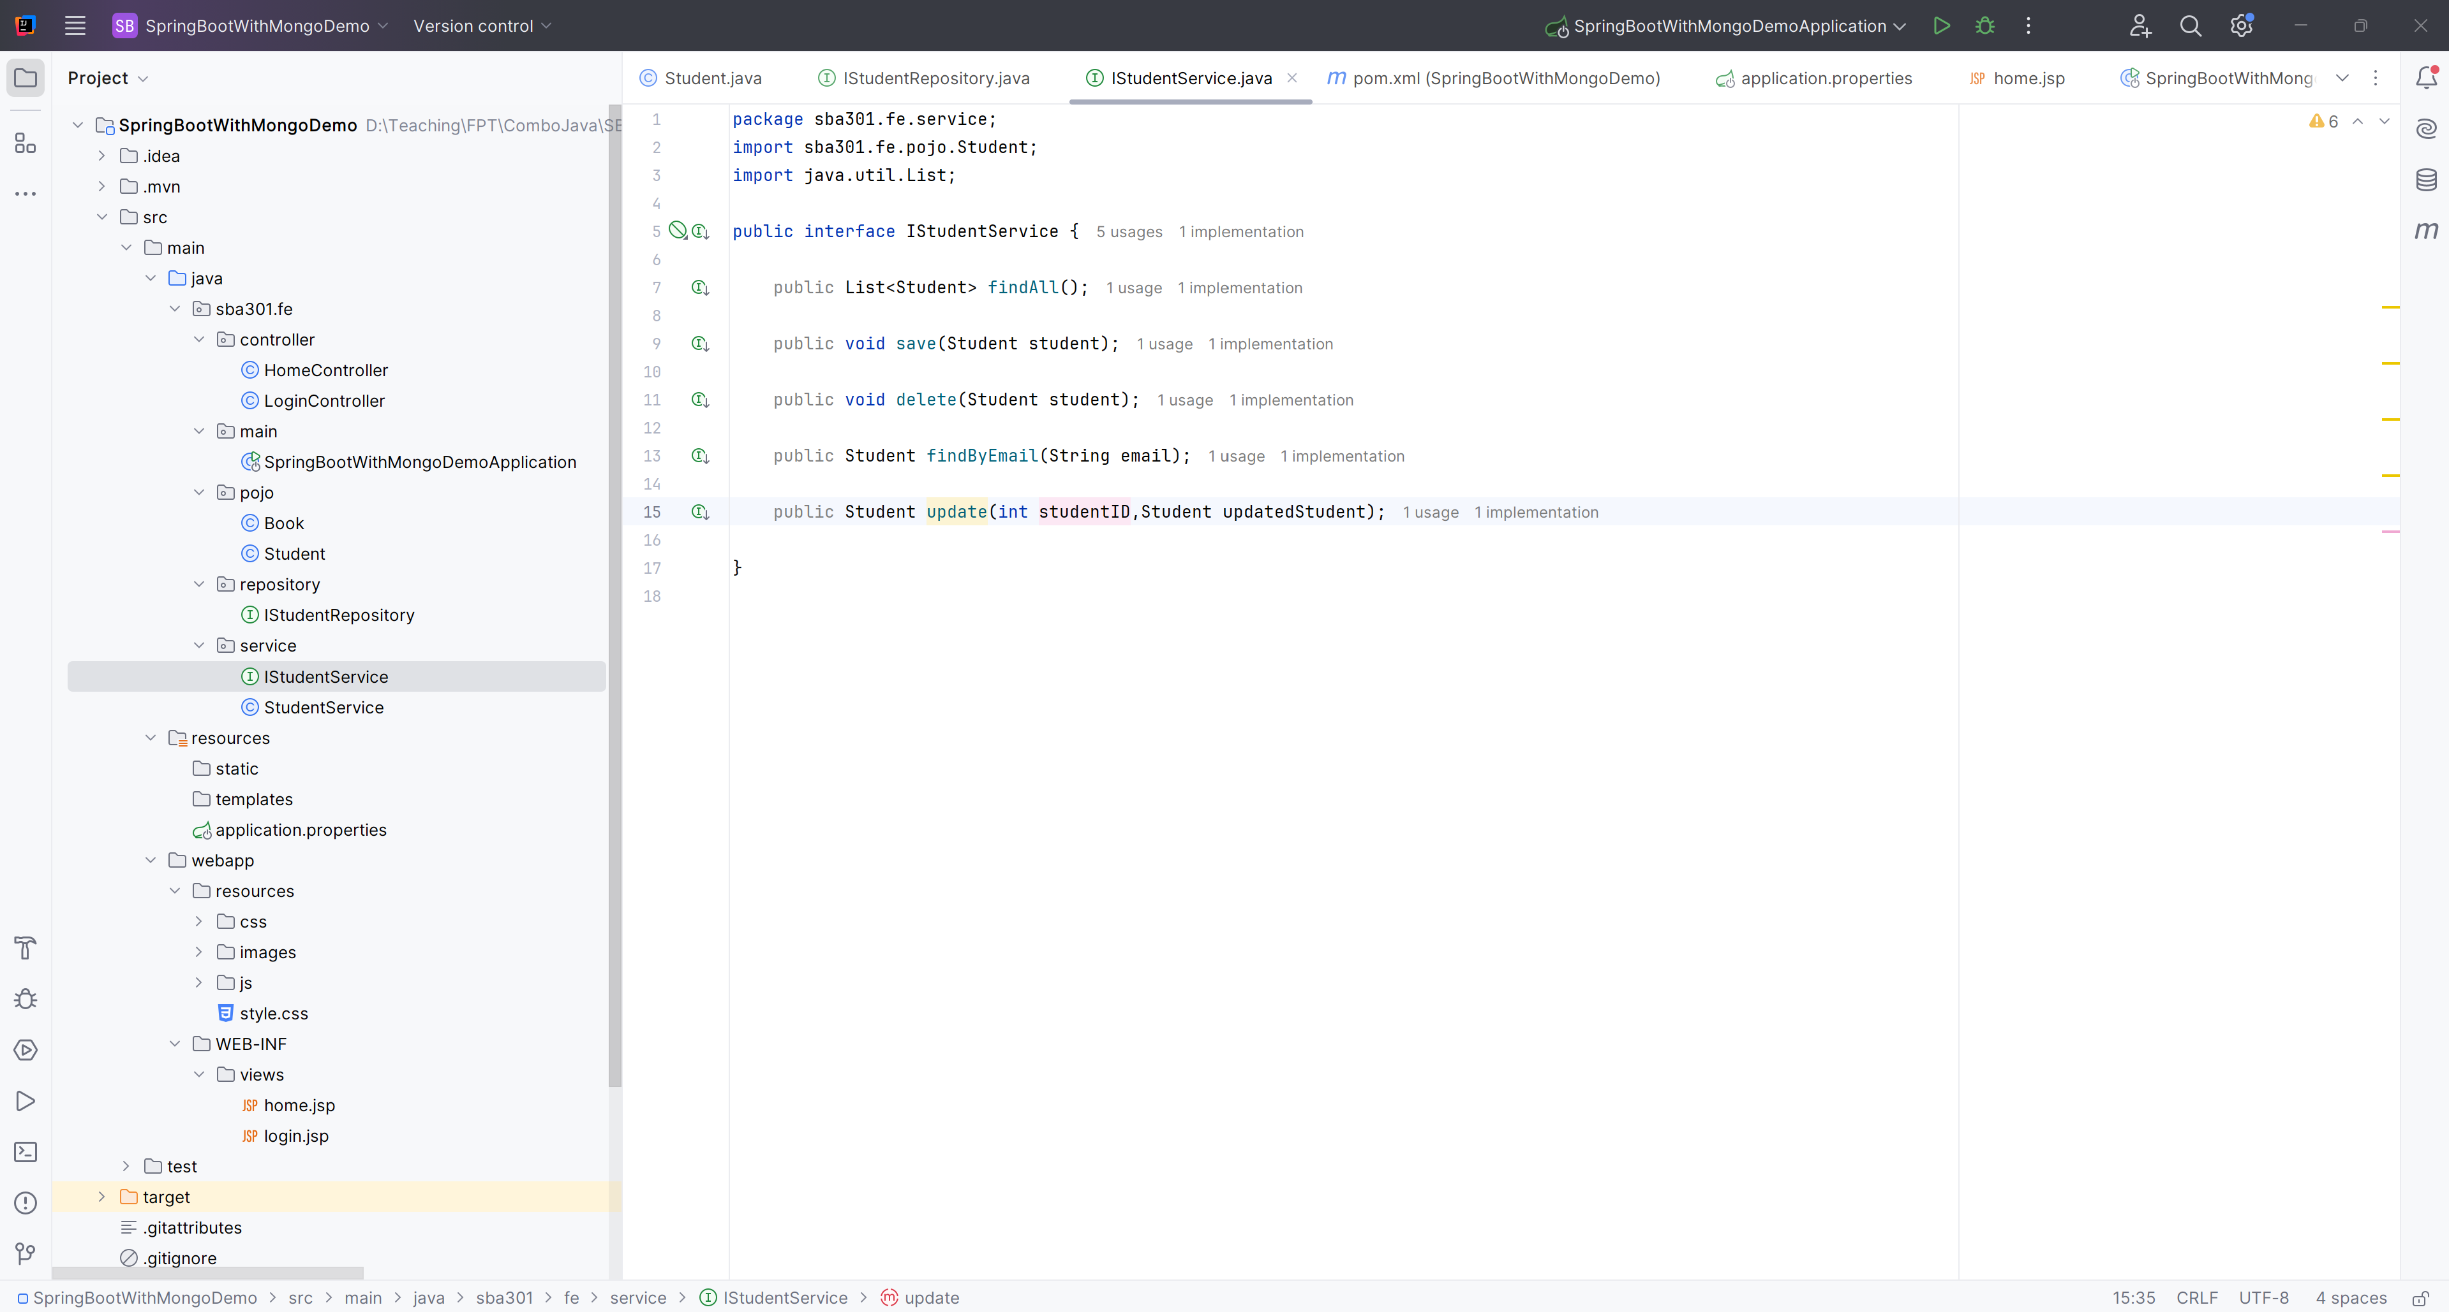

**Step 06**. Create StudentService in Service Package

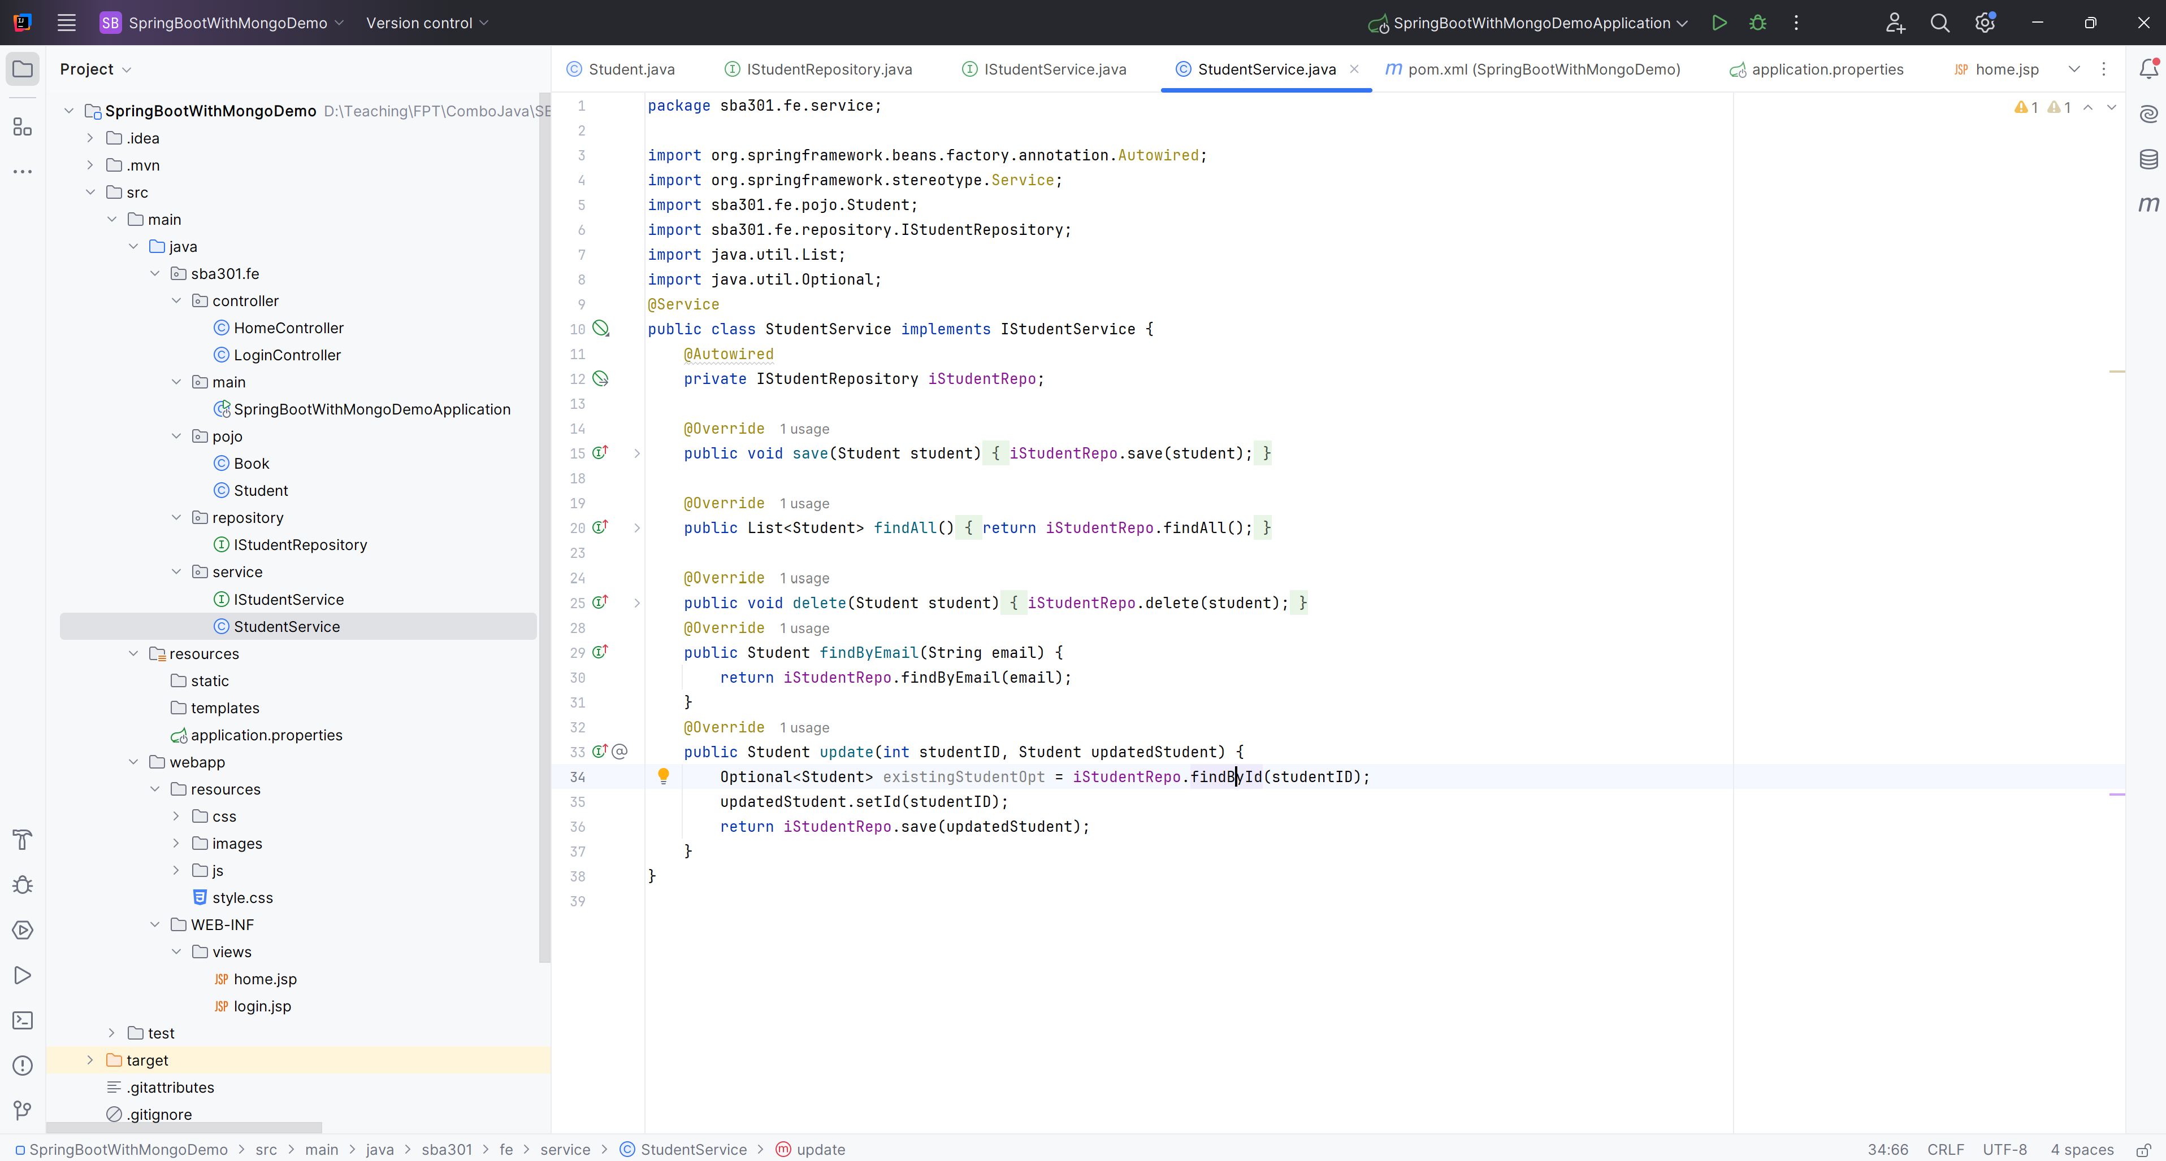

**Step 07**. Edit HomeController.java

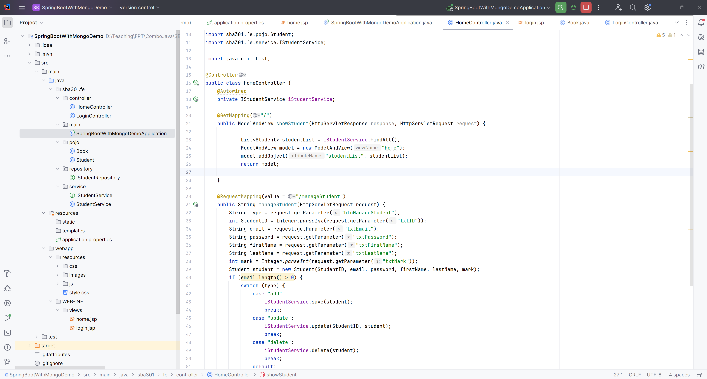

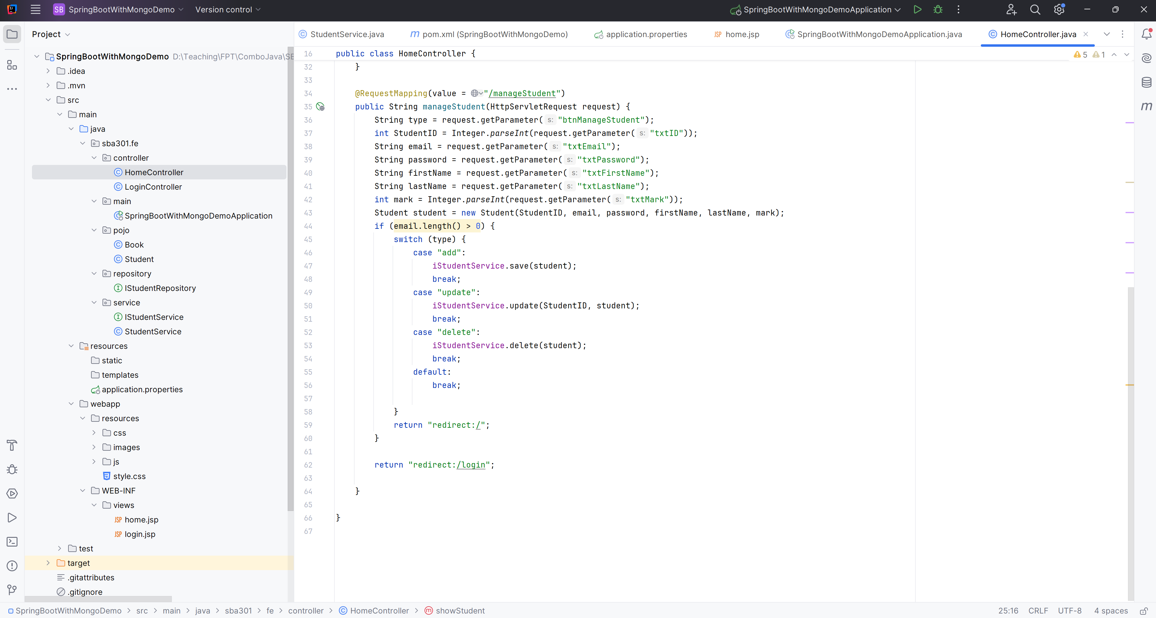

**Step 08**. Create the LoginController.java

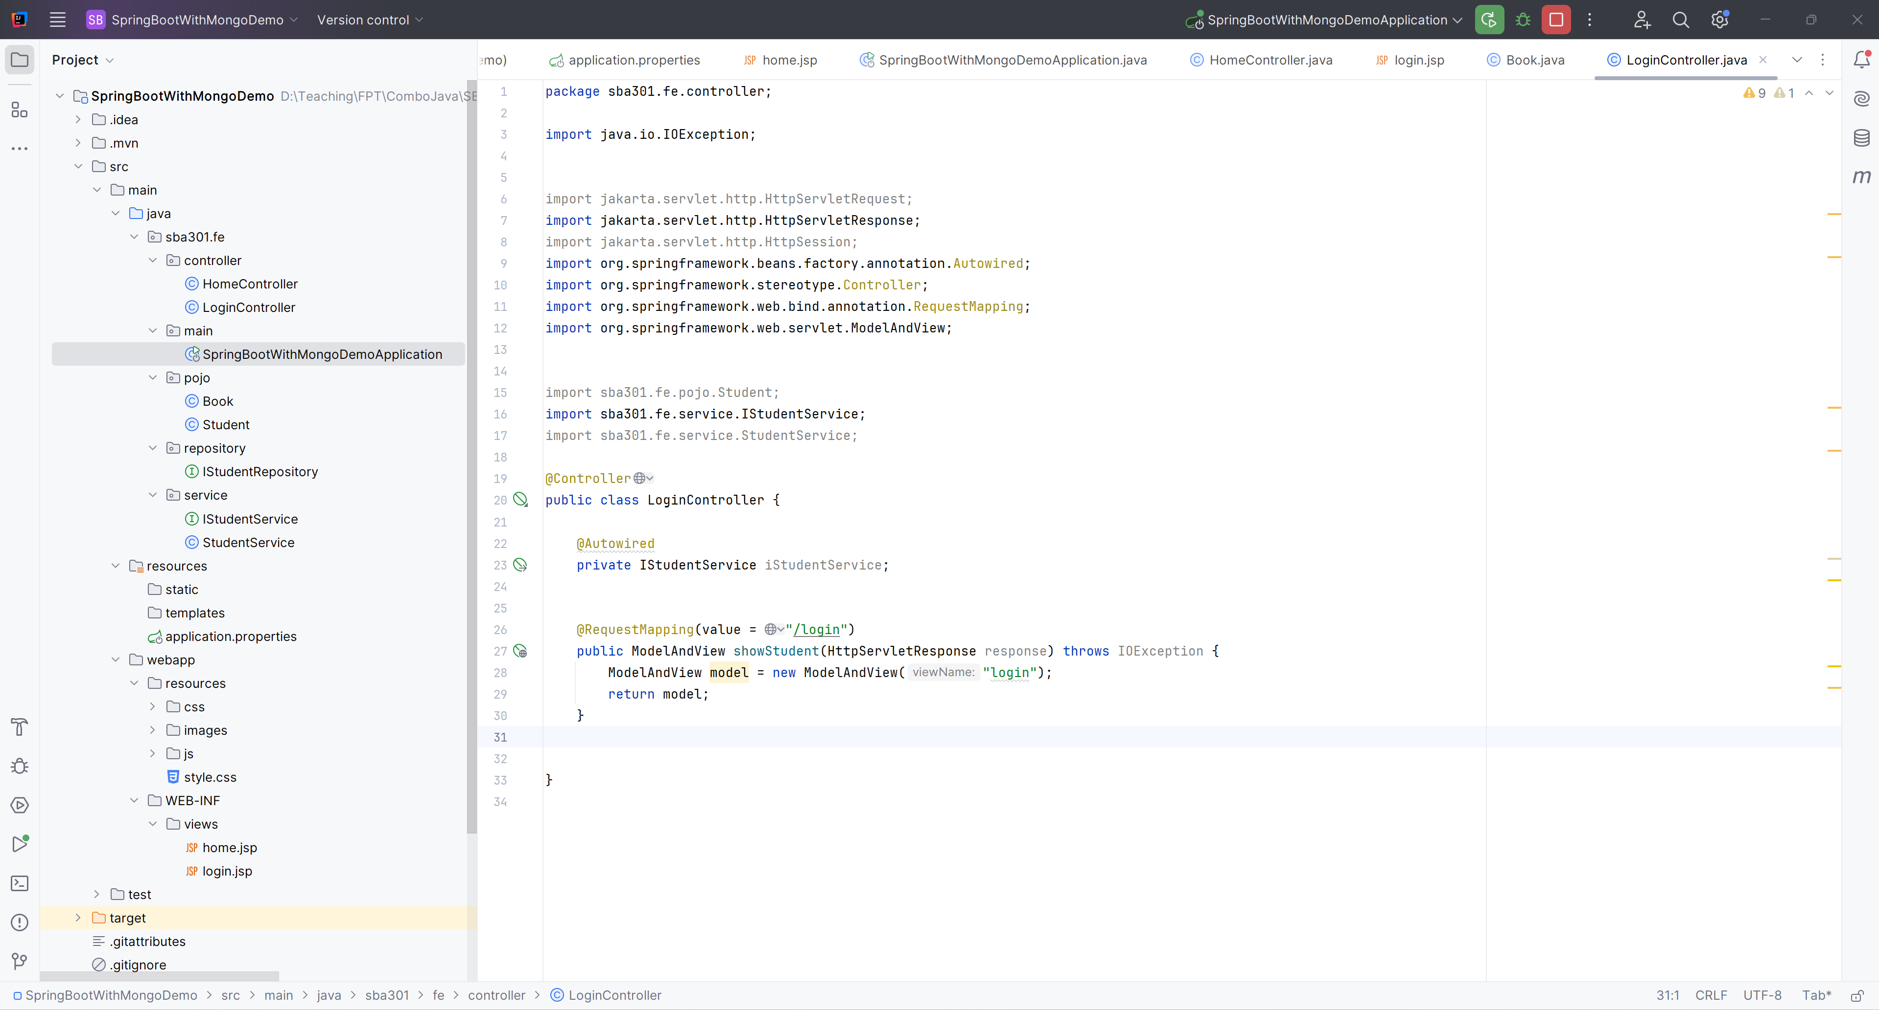

**Step 08**. Edit Main.java

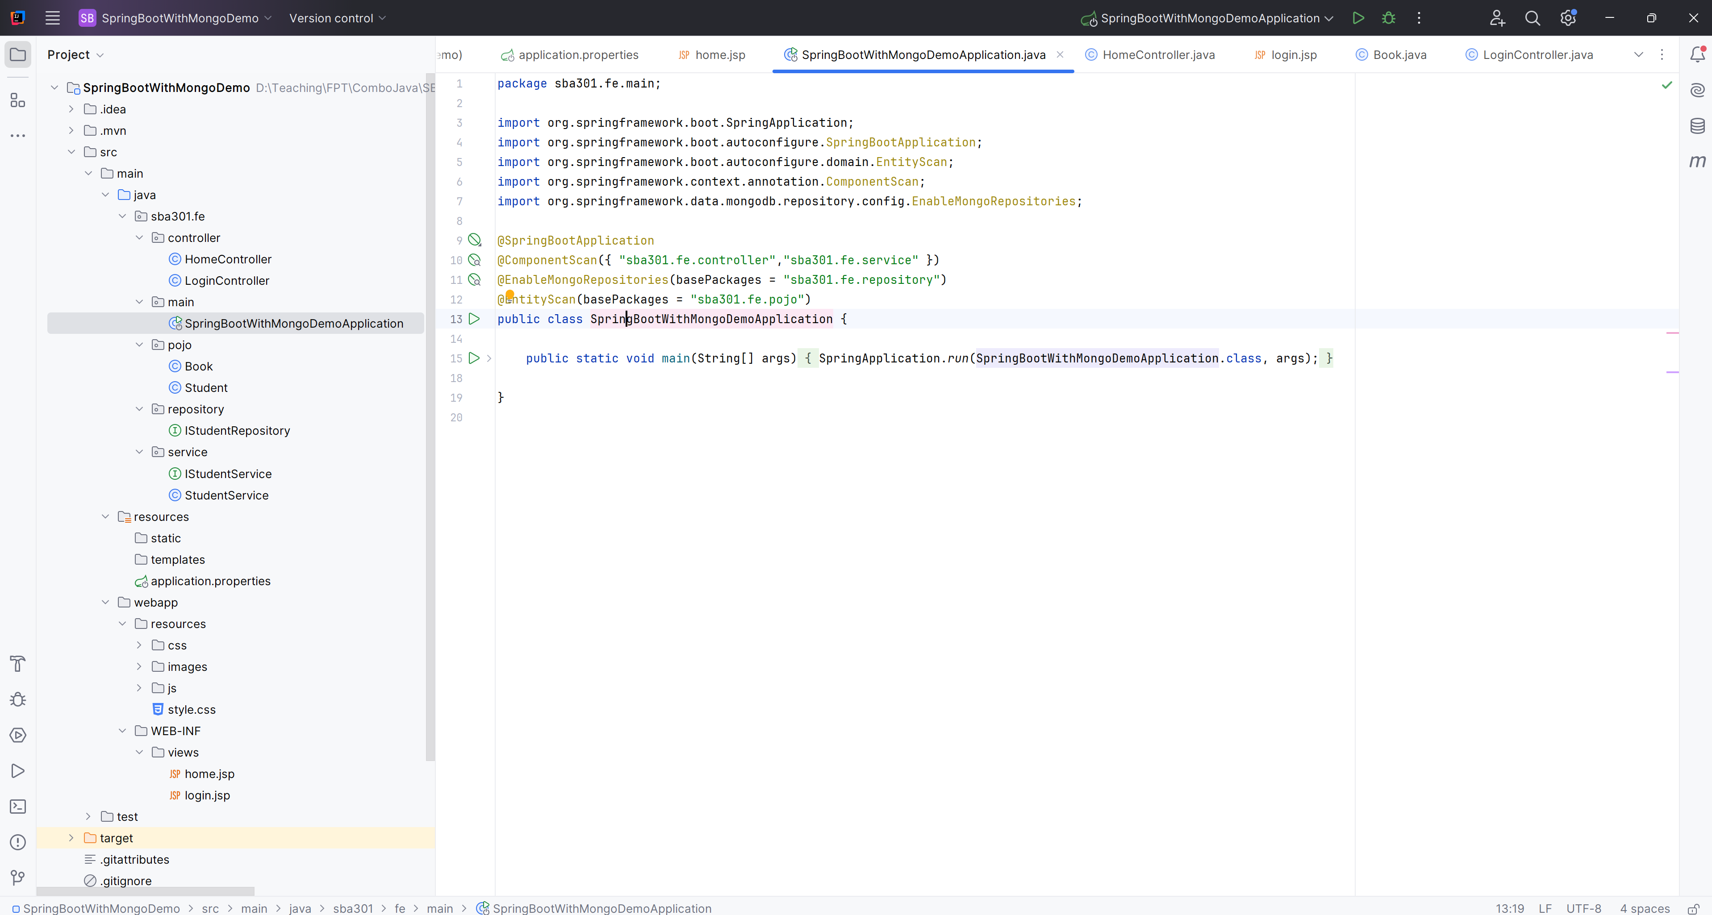

**Step 09**. Run As Server

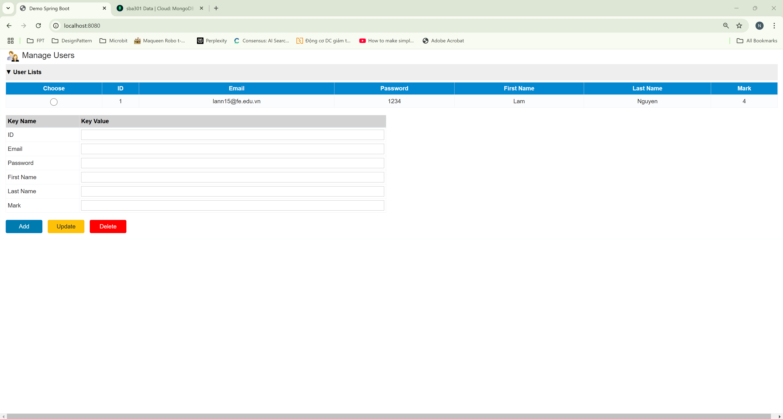

# Activity 03: Design and Develop the Login Page

**Step 01**. Edit LoginController.java in Controller Package

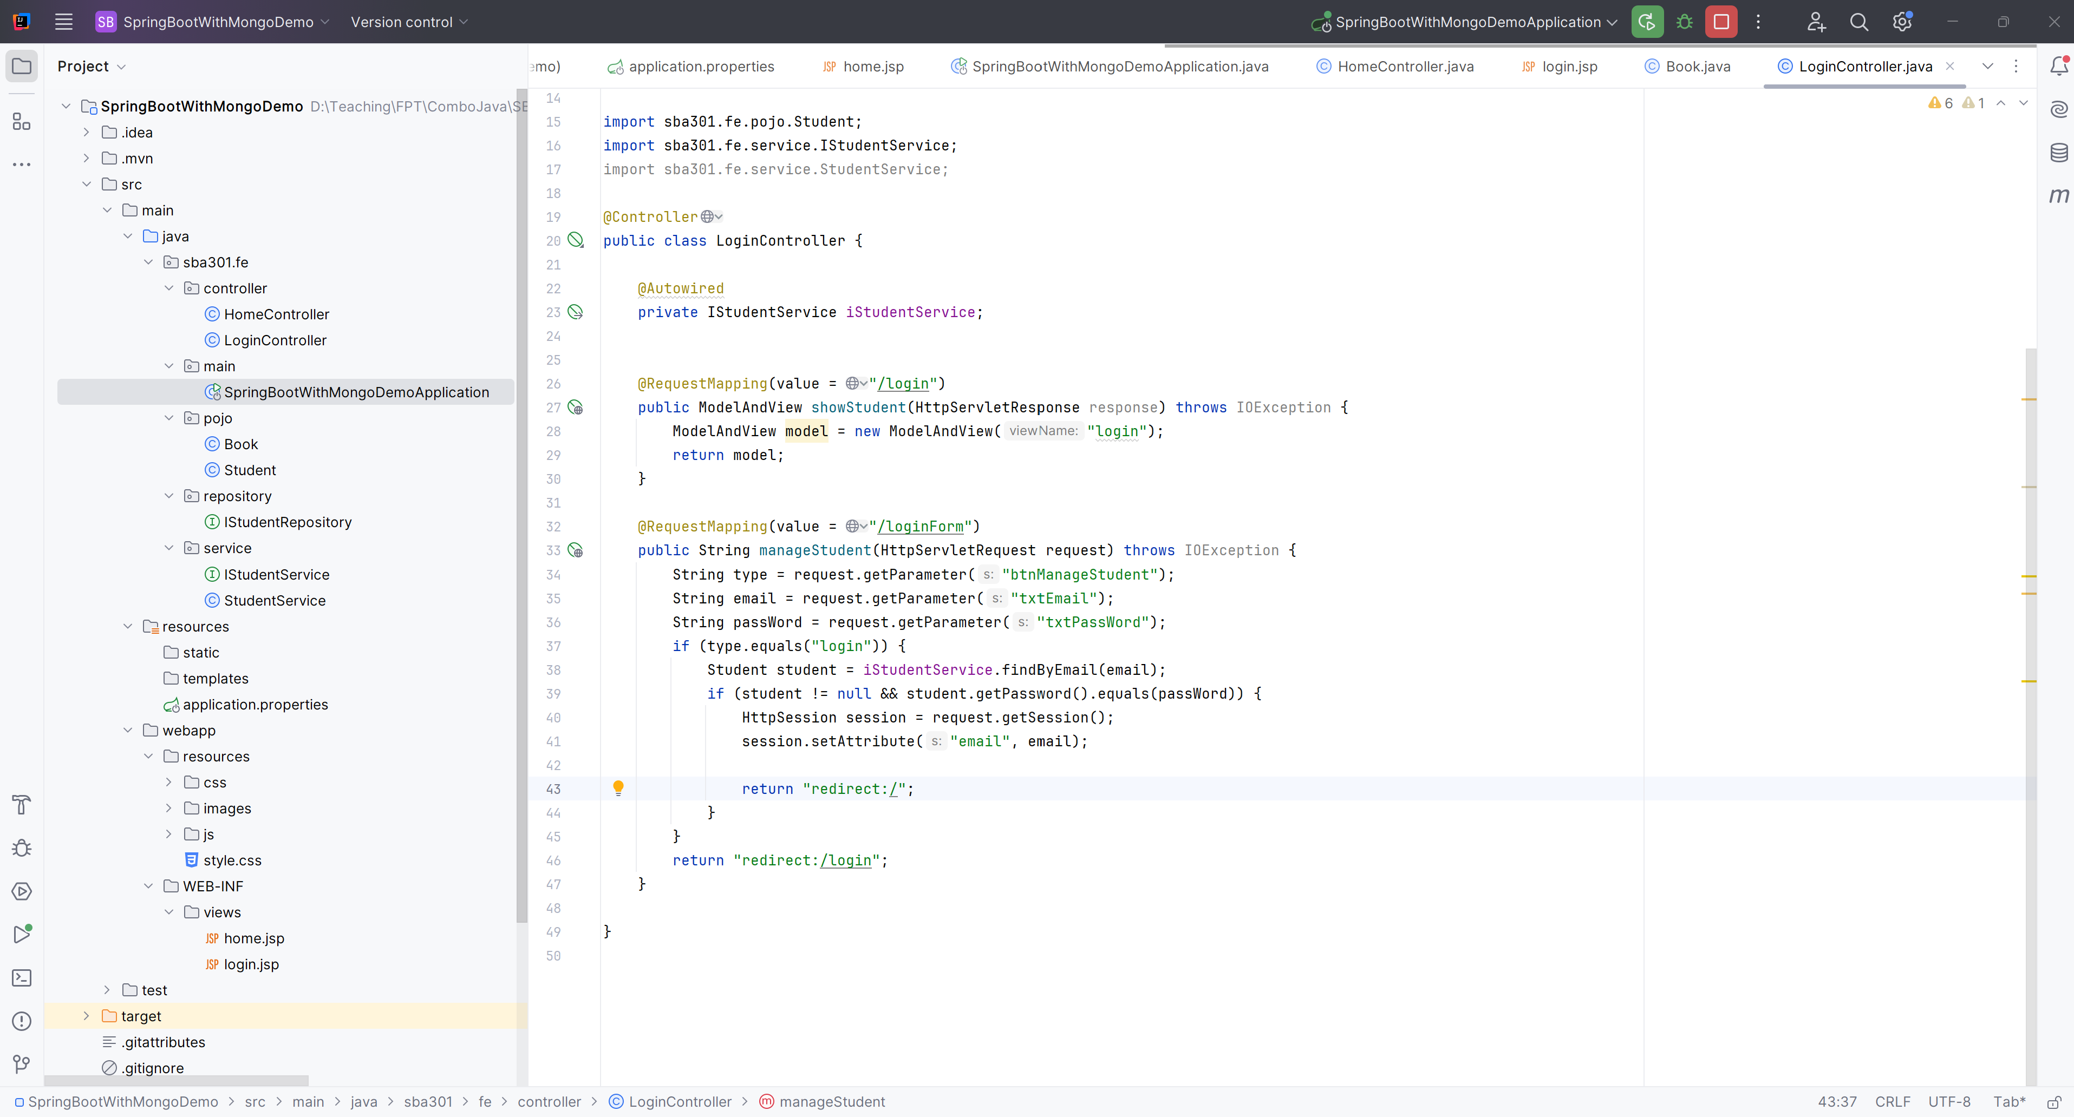

**Step 02**. Edit HomeController.java to check the Session

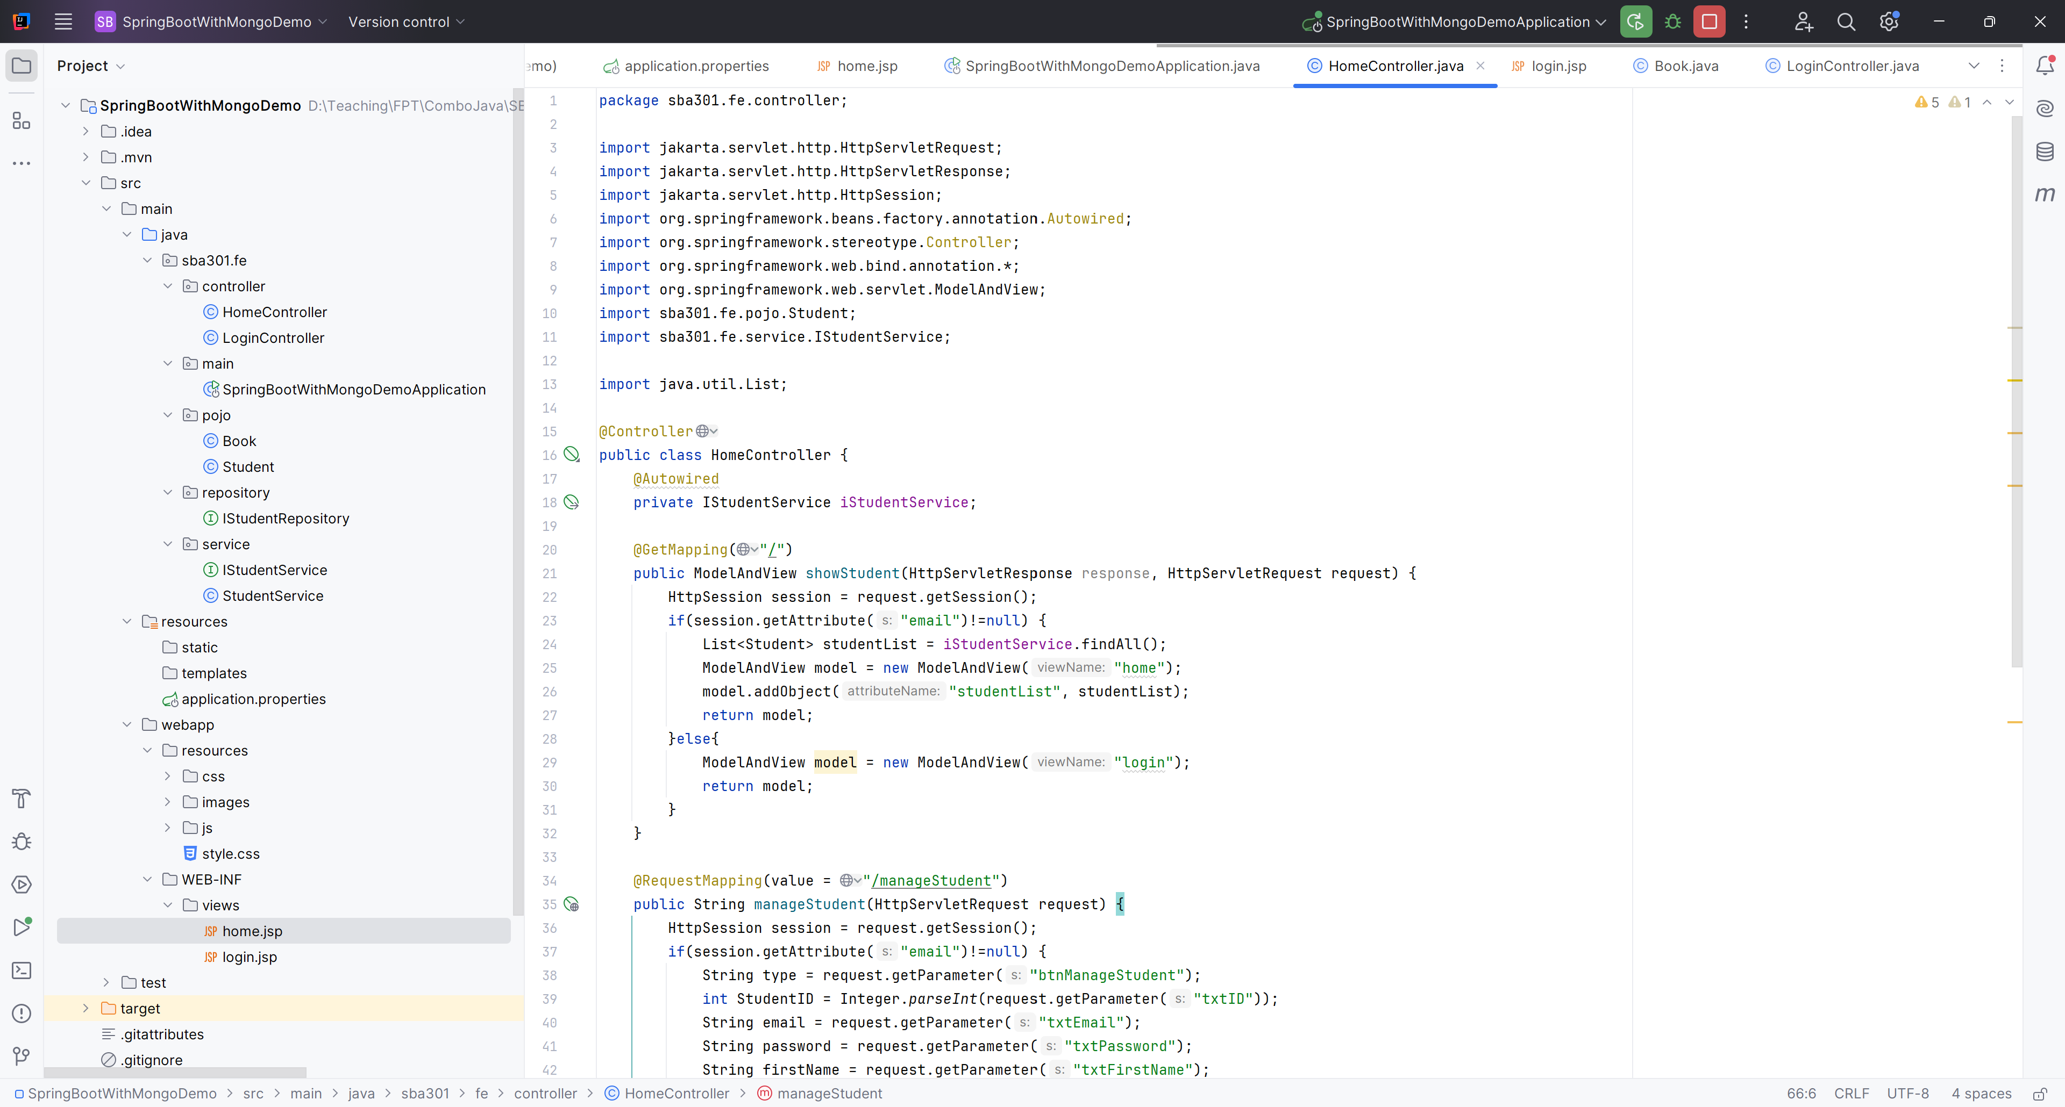

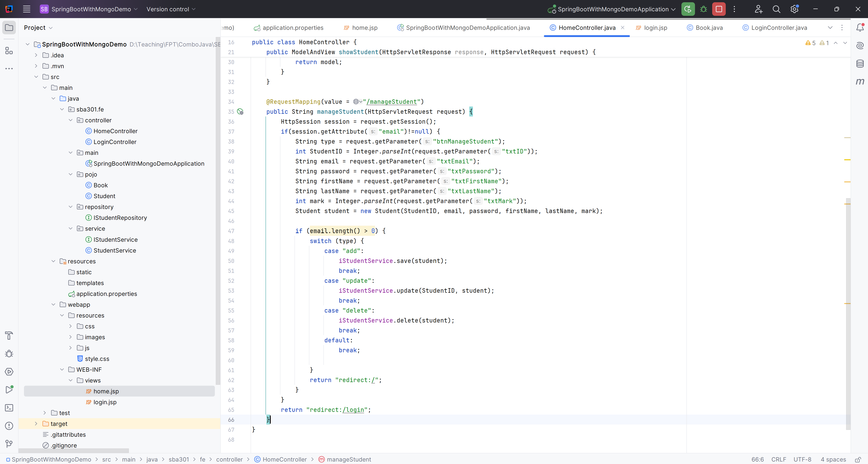

**Step 03**. Run As Server  
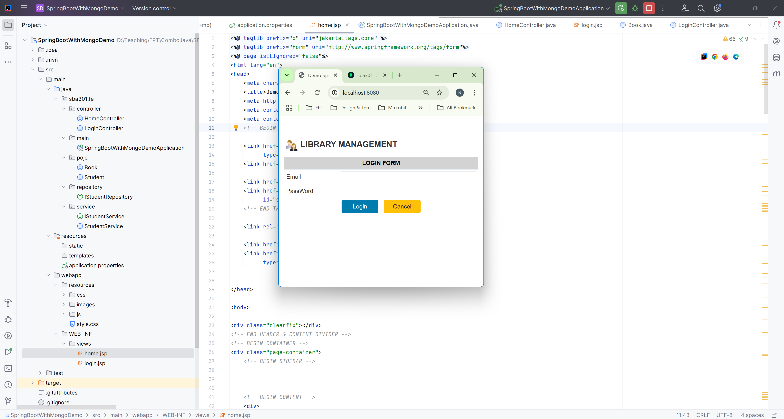

After Login Success

